Entering the German mid-market can add €40M revenue by 2028
Strategy team
EXECUTIVE SUMMARY

Entering Germany now captures a €40M window before two rivals scale
Decision requested: Approve a €6M phase-1 budget and the partner shortlist at this meeting
SITUATION
Our UK mid-market business grew 18% a year since 2022 and now funds itself; the product is proven in a regulated market.
COMPLICATION
Two well-funded competitors are preparing German launches in 2027, and switching costs make early share sticky.
RESOLUTION
Enter Germany in 2027 through a partner-led model, scaling direct sales only after 40 reference clients.
Illustrative data. Source: Northwind management accounts FY2025; Strategy team market model, Oct 2026
If the board reads only this page, it can make the decision.
[Sources]
- Northwind management accounts FY2025 — illustrative data
- Strategy team market model, Oct 2026 — illustrative data
WHY CHANGE

The UK business is profitable, growing and ready to fund a second market
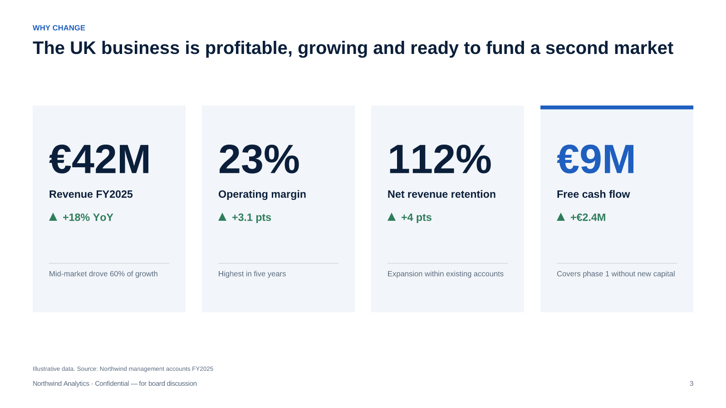
Illustrative data. Source: Northwind management accounts FY2025
[Sources]
- Northwind management accounts FY2025 — illustrative data
WHY CHANGE

The German mid-market is three times our UK base and still under-served
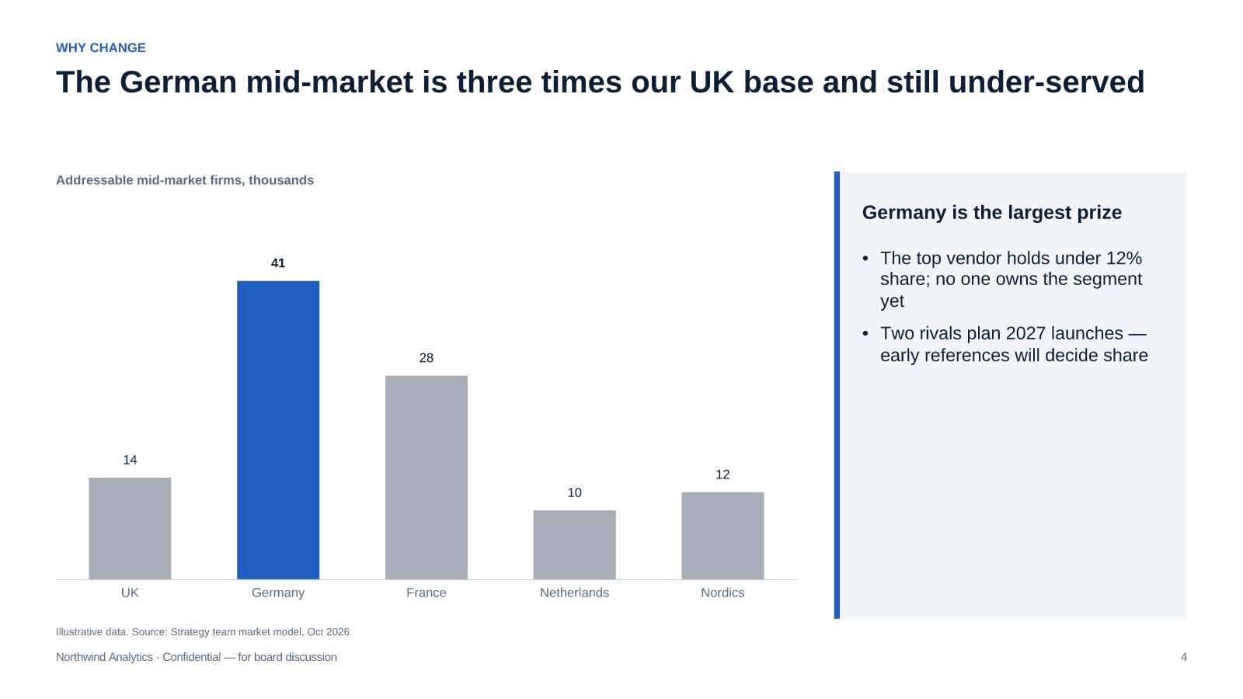
Illustrative data. Source: Strategy team market model, Oct 2026
[Sources]
- Strategy team market model, Oct 2026 — illustrative data
THE RECOMMENDATION

A partner-led entry beats direct build and acquisition on speed and risk
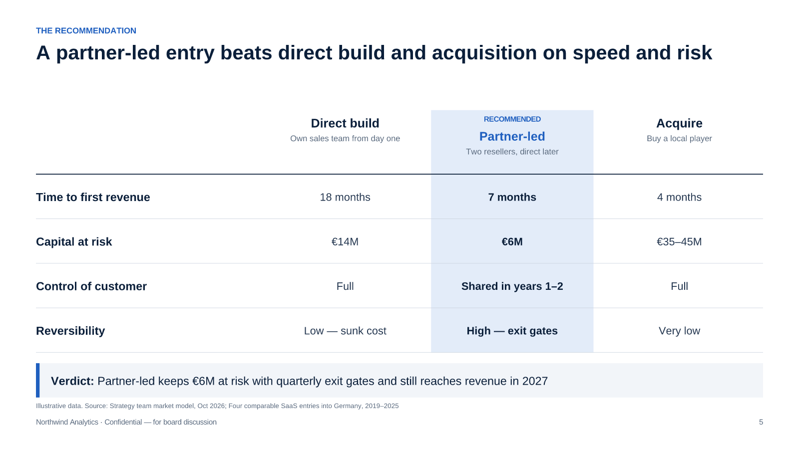
Illustrative data. Source: Strategy team market model, Oct 2026; Four comparable SaaS entries into Germany, 2019–2025
[Sources]
- Strategy team market model, Oct 2026 — illustrative data
- Four comparable SaaS entries into Germany, 2019–2025 — illustrative data
THE RECOMMENDATION

Partners cut time to first revenue from 18 to 7 months
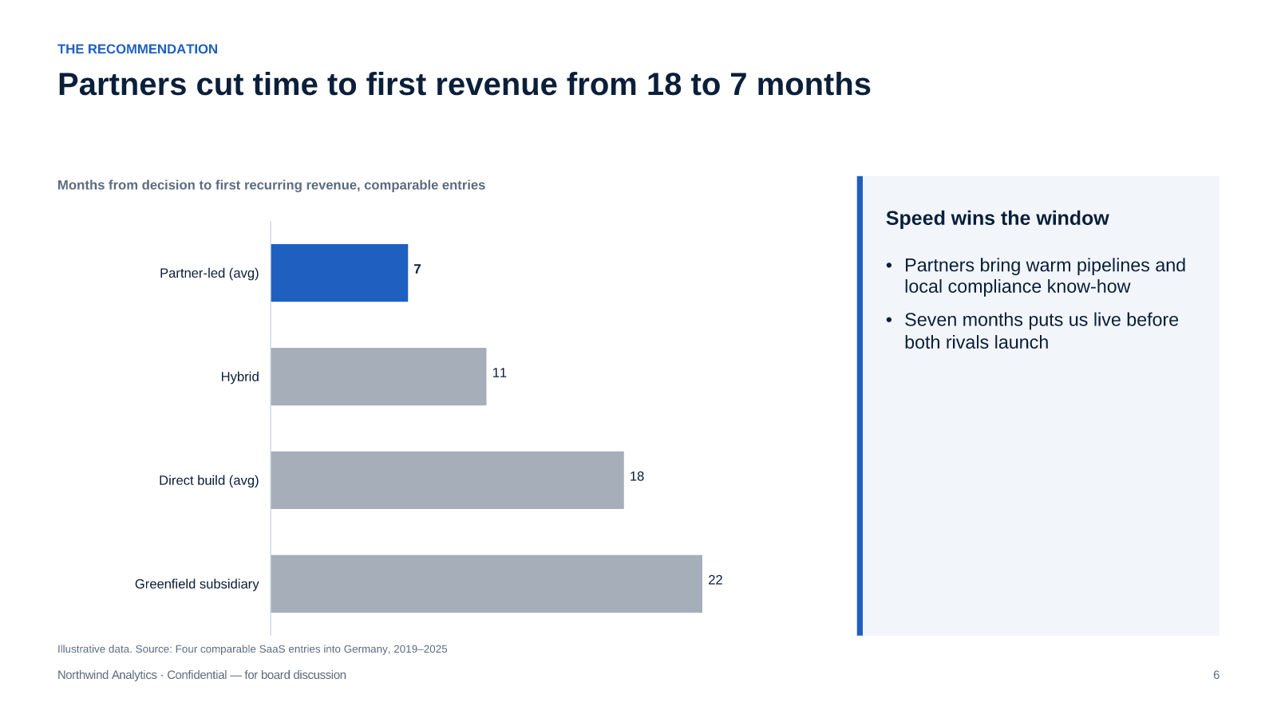
Illustrative data. Source: Four comparable SaaS entries into Germany, 2019–2025
[Sources]
- Four comparable SaaS entries into Germany, 2019–2025 — illustrative data
THE RECOMMENDATION

Germany adds €40M by 2028 on top of a growing UK base
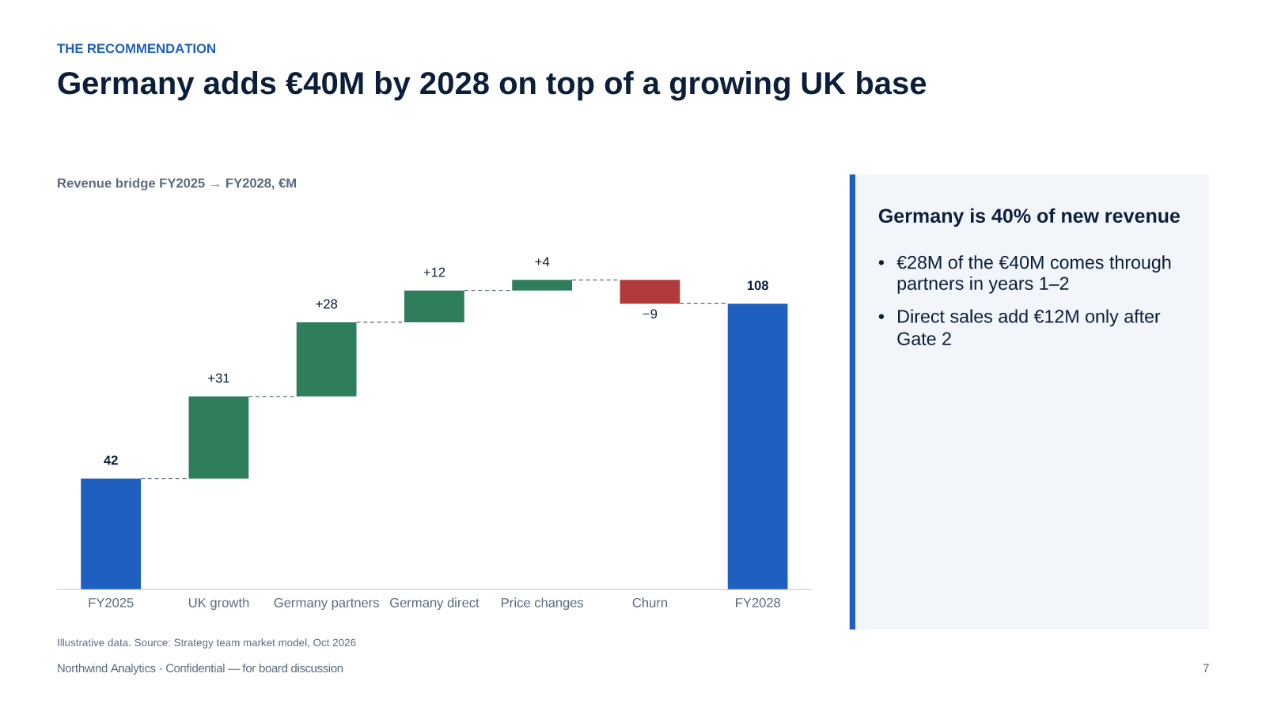
Illustrative data. Source: Strategy team market model, Oct 2026
[Sources]
- Strategy team market model, Oct 2026 — illustrative data
HOW WE GET THERE

Localisation is the critical path; direct sales scale only after Gate 2
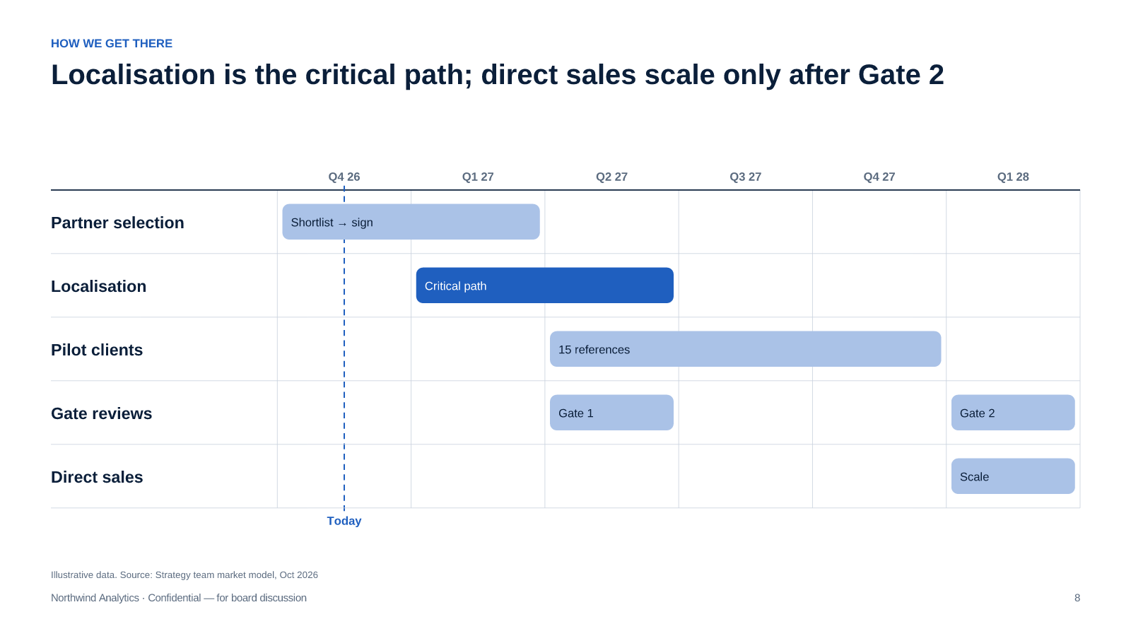
Illustrative data. Source: Strategy team market model, Oct 2026
[Sources]
- Strategy team market model, Oct 2026 — illustrative data
HOW WE GET THERE

Three risks matter most, and each has an owner and an early signal
Risk | Likelihood | Impact | Mitigation | Owner
Partners under-deliver pipeline | Medium | High | Two partners with quarterly targets and exit clauses | Strategy
Localisation slips past Q2 2027 | Medium | High | Dedicated squad; scope frozen at German UI and hosting | Product
Rivals undercut on price | High | Medium | Lead on compliance and service; price floor agreed with CFO | Sales

Illustrative data. Source: Strategy team market model, Oct 2026
[Sources]
- Strategy team market model, Oct 2026 — illustrative data
DECISION

Decision today: approve phase 1 so partners can be signed by January
DECISION REQUESTED
Approve the €6M phase-1 budget and the shortlist of two German partners
1
Sign letters of intent with the two shortlisted partners
Strategy · 28 Nov
2
Stand up the localisation squad and freeze scope
Product · 5 Dec
3
Register the German entity and open accounts
Finance · 19 Dec
4
First quarterly gate review with the board
CEO · Mar 2027
Illustrative data. Source: Strategy team market model, Oct 2026
[Sources]
- Strategy team market model, Oct 2026 — illustrative data

Questions and discussion
Appendix with market model and partner profiles available on request
strategy@northwind.example

