SlideCraft turns a goal into a partner-ready deck you can edit
Denis Ermilov · SlideCraft · 2026

Most of a deck's time goes into work that is not thinking
Formatting, fitting text, chasing sources and fixing alignment take the hours that should go into the argument.
Ask the room how long their last board deck took, and how much of that was formatting.
IN ONE PAGE

SlideCraft applies consulting rules automatically and leaves you the decisions
Decision requested: Try it on your next board, client or pitch deck
SITUATION
Decks drive decisions. Boards, steering committees, clients and investors judge the work by the pages they see.
COMPLICATION
Good decks follow strict rules — answer first, one claim per slide, every number sourced — and applying them by hand is slow and uneven.
RESOLUTION
SlideCraft builds the deck from a brief with your AI assistant, applies the rules on every slide and checks the result before you see it.
HOW IT WORKS

Four checkpoints keep you in charge while the assistant does the work
You approve steps 1, 2, 3 and 5; everything in between is automated.
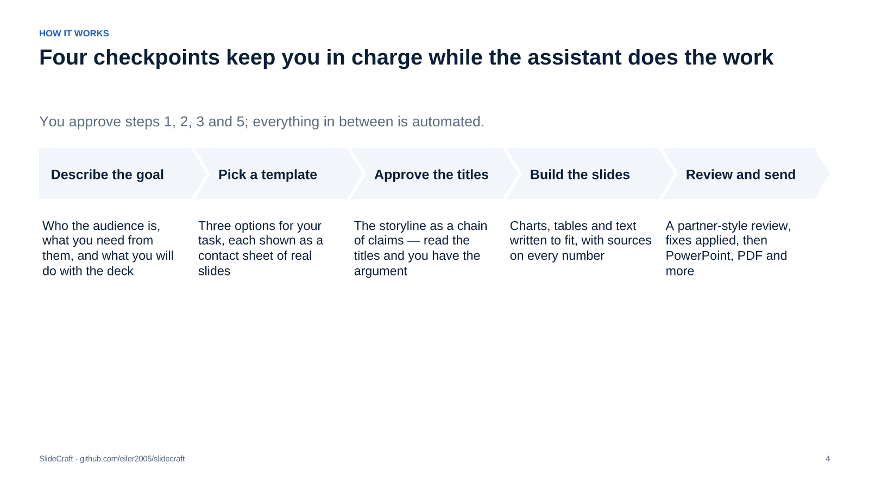
WHAT CHANGES

The same deck, without the late-night rework
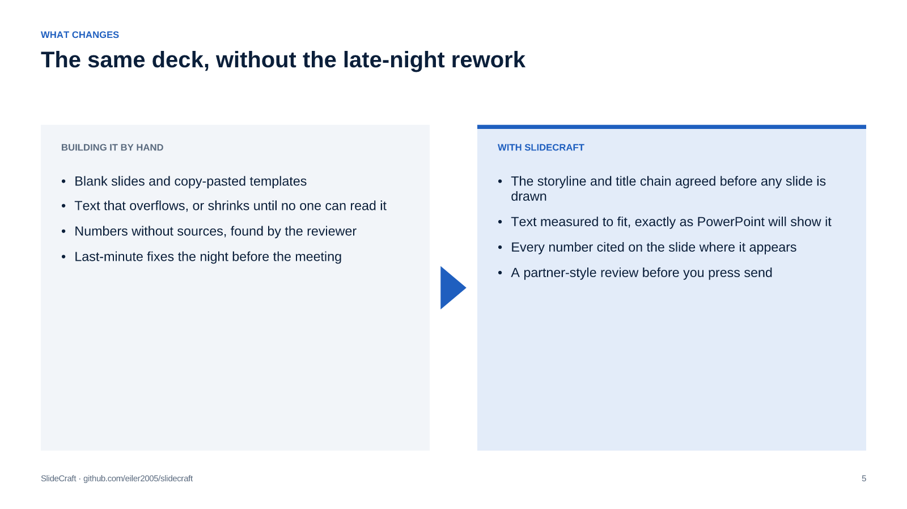
WHO IT HELPS

It helps everyone who has to convince people with slides
Consultants and strategy teams
Managers and executives
Founders and sales teams
Speakers and trainers
Board-ready recommendations with an answer-first storyline, issue trees and options on shared criteria.
Steering-committee updates, business cases and QBRs that show plan, actual and the decision needed.
Pitch decks and client proposals that lead with the problem, the proof and a clear ask.
Story-led talks and workshops, presented from the browser or sent as a PDF.
CHOOSE YOUR TASK

Pick the storyline for your task; the look is a separate choice
Your task | Storyline | Typical audience
Recommend a strategy | Strategy recommendation | Board, leadership team
Report progress | Executive update | Steering committee
Win a client | Client proposal | Buyer, procurement
Ask for budget | Business case | CFO, investment committee
Raise money | Pitch deck | Investors
Review a quarter | Sales QBR | Customer executives
Tell a story | Narrative story | Conference, all-hands

Source: SlideCraft 0.4 release notes and test suite (Oct 2026)
[Sources]
- SlideCraft 0.4 release notes and test suite — Oct 2026 — https://github.com/eiler2005/slidecraft/blob/main/CHANGELOG.md
WHAT YOU GET

One brief gives you a complete kit, not just slides
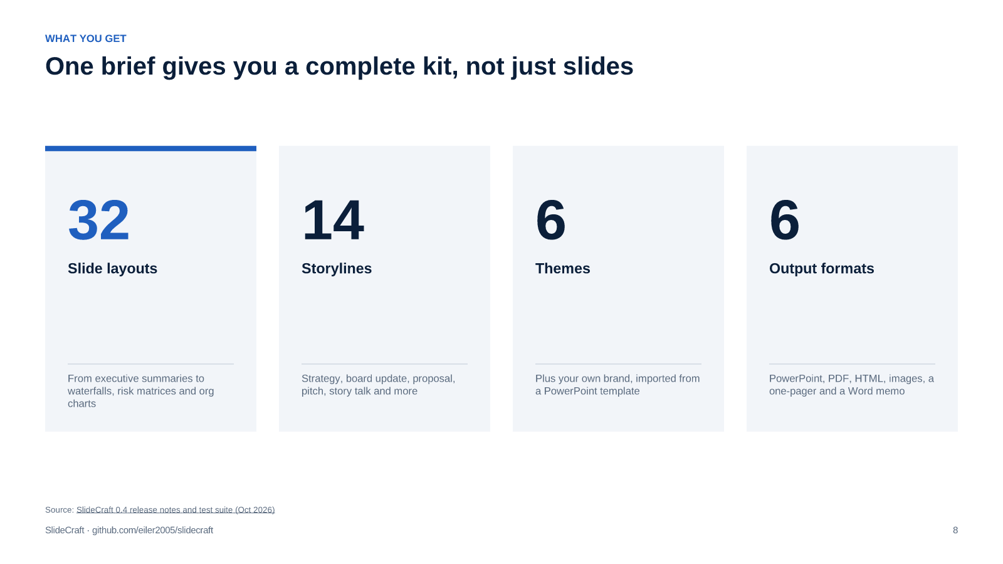
Source: SlideCraft 0.4 release notes and test suite (Oct 2026)
[Sources]
- SlideCraft 0.4 release notes and test suite — Oct 2026 — https://github.com/eiler2005/slidecraft/blob/main/CHANGELOG.md
QUALITY

Every deck is checked before you see it, not after the meeting
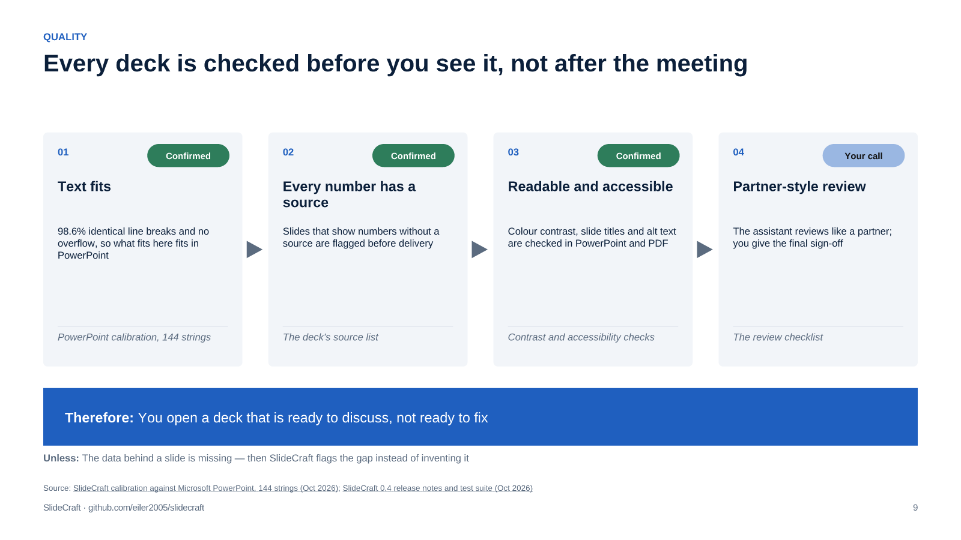
Source: SlideCraft calibration against Microsoft PowerPoint, 144 strings (Oct 2026); SlideCraft 0.4 release notes and test suite (Oct 2026)
[Sources]
- SlideCraft calibration against Microsoft PowerPoint, 144 strings — Oct 2026 — https://github.com/eiler2005/slidecraft/blob/main/docs/how-to/apply-brand.md
- SlideCraft 0.4 release notes and test suite — Oct 2026 — https://github.com/eiler2005/slidecraft/blob/main/CHANGELOG.md
FITS YOUR WORK

Your brand, your old decks and your readers all come along
Your template, your look
Old decks, restyled
The format each reader needs
Import a .potx once. Colours, fonts, logo and layouts apply, and PowerPoint files are built inside your template.
Bring an existing PowerPoint. The assistant rewrites the titles as claims and rebuilds the charts from the data.
A PDF for the board, a one-page summary, a Word memo for pre-reading, an HTML deck for presenting.
GET STARTED

Start with your next deck in about ten minutes
DECISION REQUESTED
Try SlideCraft on one real deck this week
1
Install it for your AI assistant — Claude Code, Codex, Cursor or another
You · 2 min
2
Say what the deck must achieve and for whom
You · 1 min
3
Approve the template, the titles and the review
You · 5 min
4
Open the PowerPoint and PDF, then edit freely
You · Done

Describe the goal. Pick a look. Ship a partner-ready deck.
Free to use under the PolyForm Shield licence
github.com/eiler2005/slidecraft
eiler2005.github.io/slidecraft

