Fabrikam turns idle truck space into same-day freight
Fabrikam Freight

Every third truck on the road is driving with empty space
31%
of regional truck capacity runs empty
Small shippers still pay for full loads or wait days for consolidated freight.
[Sources]
- Fabrikam market estimate (top-down and bottom-up), 2026 — illustrative data
SOLUTION

Shippers book spare space in minutes and it moves the same day
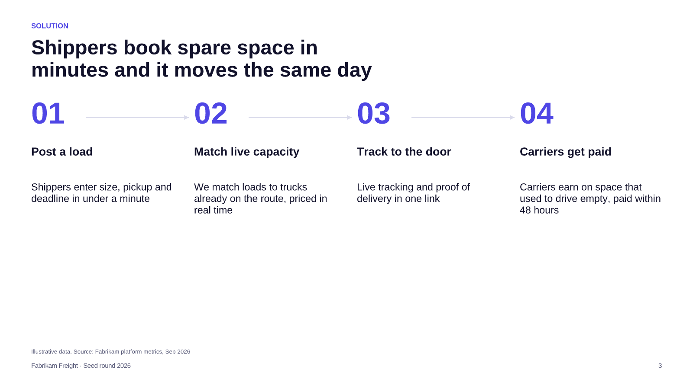
Illustrative data. Source: Fabrikam platform metrics, Sep 2026
[Sources]
- Fabrikam platform metrics, Sep 2026 — illustrative data
MARKET

Regional part-load freight is a €14B market in our first three countries
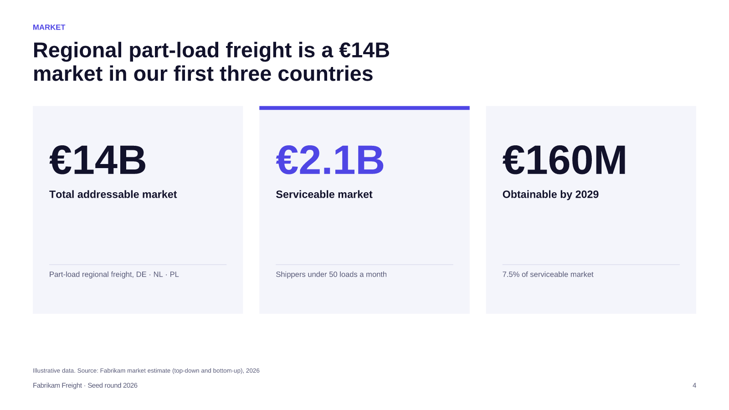
Illustrative data. Source: Fabrikam market estimate (top-down and bottom-up), 2026
[Sources]
- Fabrikam market estimate (top-down and bottom-up), 2026 — illustrative data
TRACTION

Monthly bookings grew eight-fold in nine months with no paid marketing
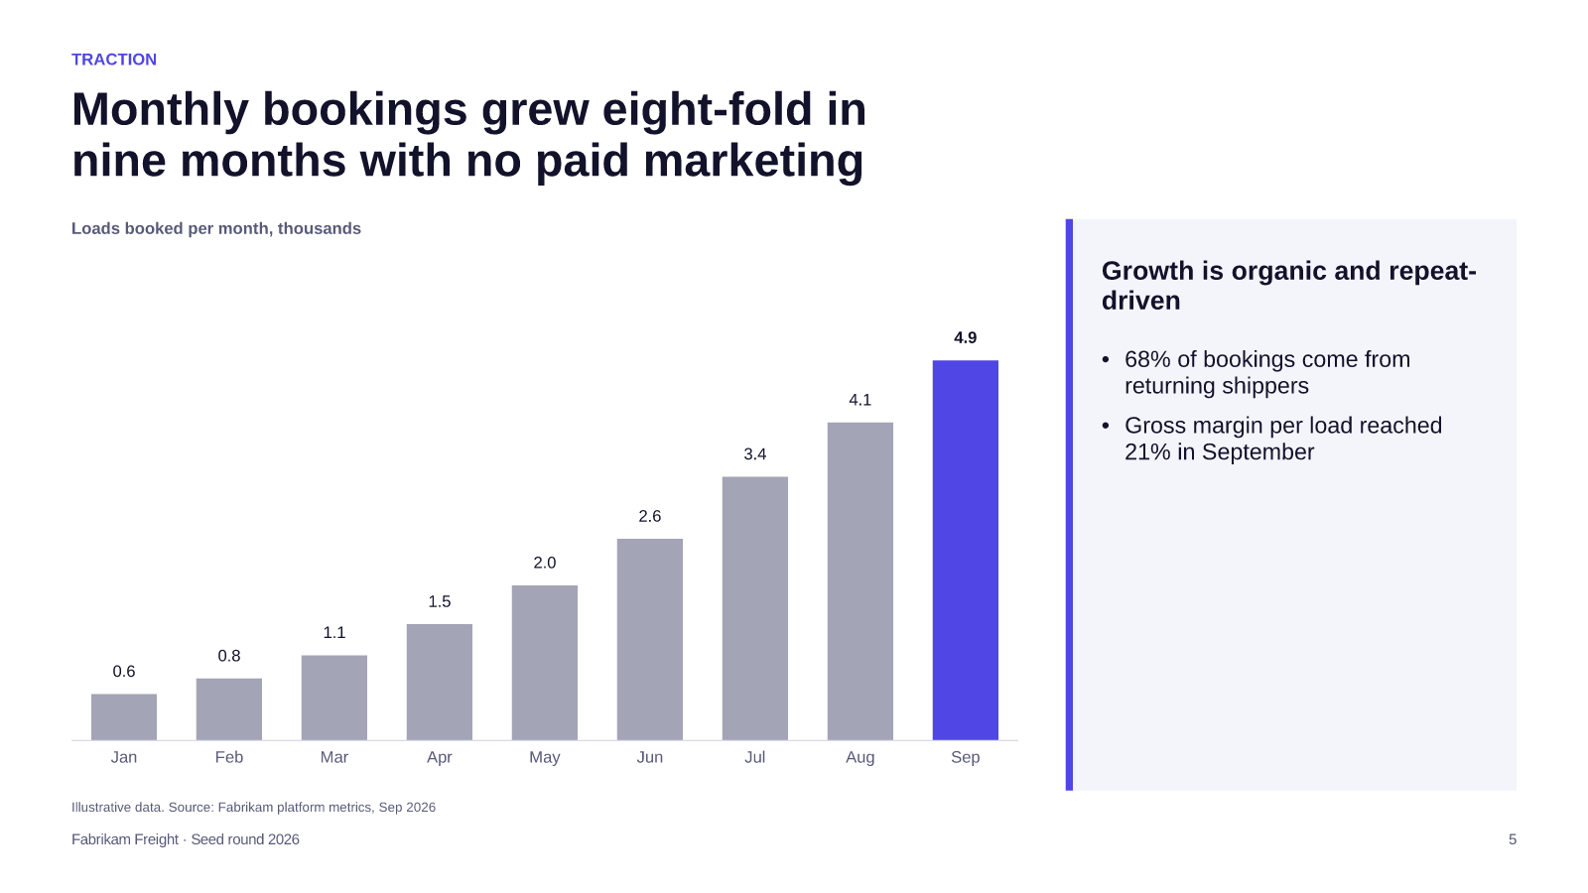
Illustrative data. Source: Fabrikam platform metrics, Sep 2026
[Sources]
- Fabrikam platform metrics, Sep 2026 — illustrative data
COMPETITION

We are the only player that is both instant and built for small shippers
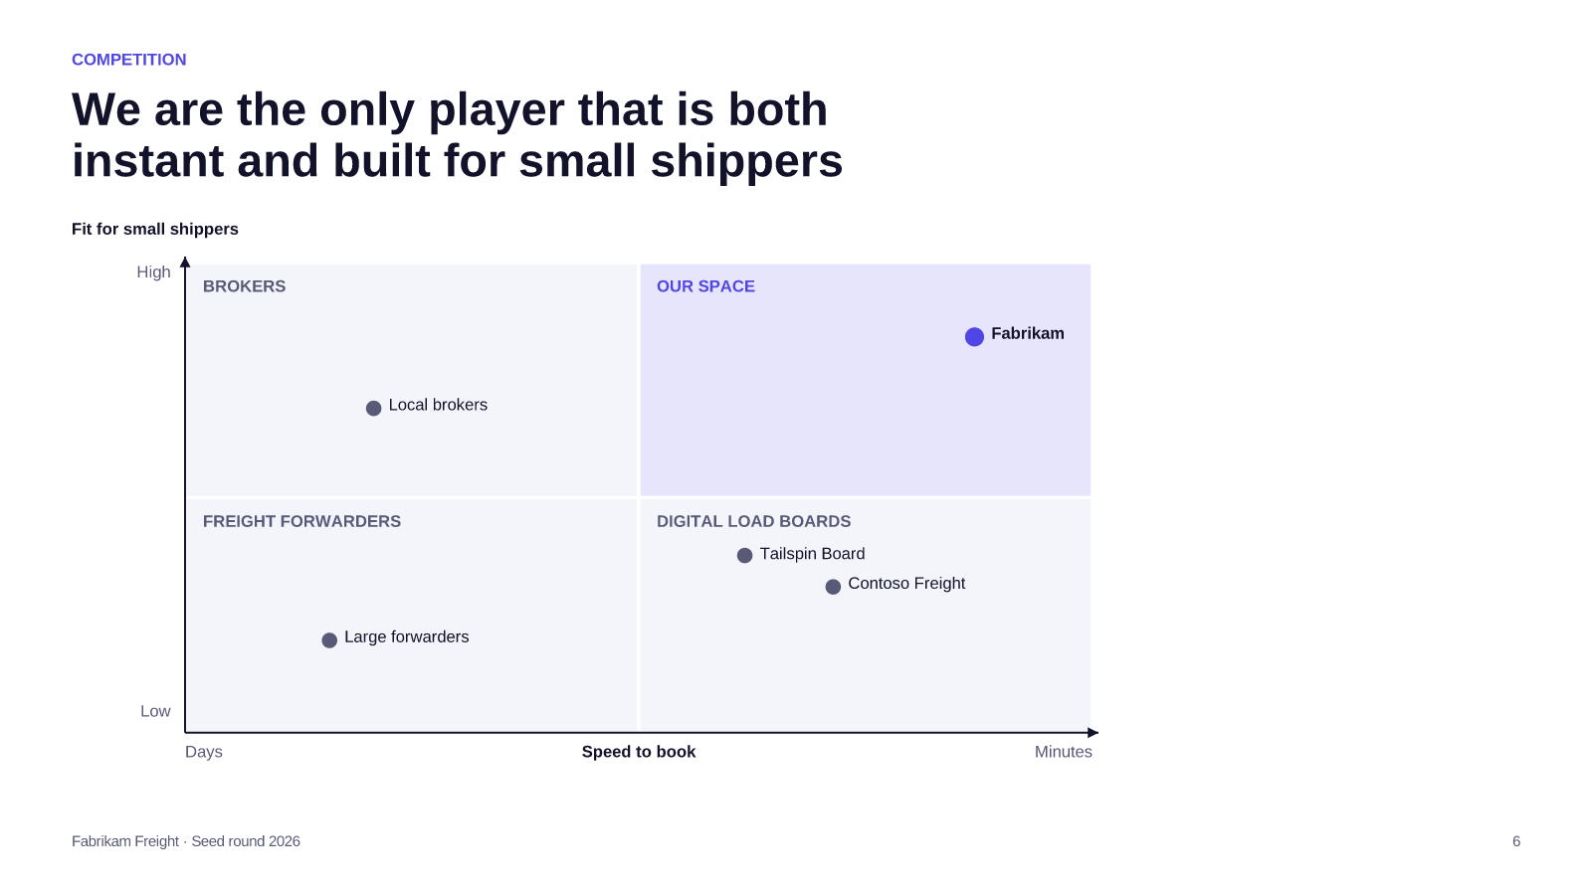
BUSINESS MODEL

Each load earns a 21% take rate and pays back acquisition in two months
Unit economics | Per load
Average booking value | €310
Take rate | 21%
Contribution after payments | €58
Shipper acquisition cost | €115
Payback | 2 months

Illustrative data. Source: Fabrikam platform metrics, Sep 2026
[Sources]
- Fabrikam platform metrics, Sep 2026 — illustrative data
TEAM

A team that has built marketplaces and run fleets
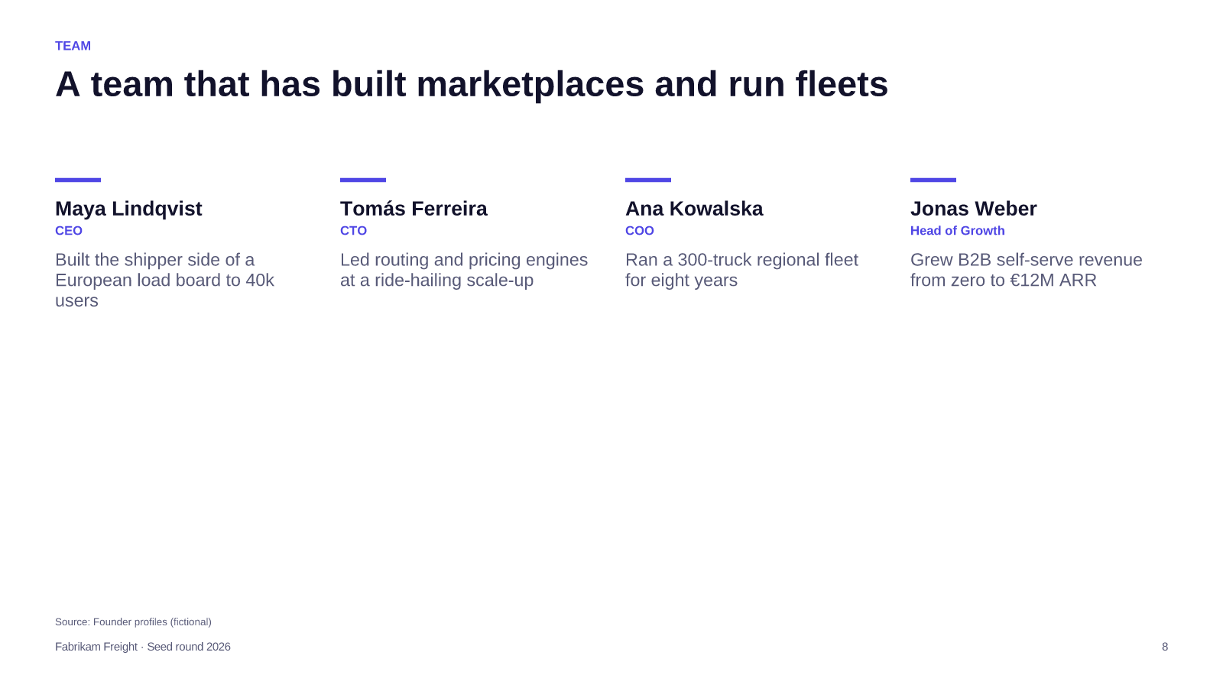
Source: Founder profiles (fictional)
[Sources]
- Founder profiles (fictional)
THE ASK

€3M seed takes us to three countries and break-even in 2028
DECISION REQUESTED
Raise €3M seed to launch the Netherlands and Poland and reach 25k loads a month
1
Launch in the Netherlands with two anchor carriers
COO · Q1 2027
2
Ship dynamic pricing v2 and carrier app
CTO · Q2 2027
3
Enter Poland via cross-border lanes
CEO · Q4 2027
Illustrative data. Source: Fabrikam platform metrics, Sep 2026
[Sources]
- Fabrikam platform metrics, Sep 2026 — illustrative data

Let's fill the empty space together
Data room and product demo available on request
maya@fabrikam.example

