We stopped closing the books and started trusting them
Finance Operations, Tailspin Logistics

Every month, forty people stopped work for two days to count money we already had
2 days
lost to the month-end close, twelve times a year
Reconciling forty bank accounts by hand, while sales, ops and auditors waited for the numbers.
[Sources]
- Tailspin Logistics finance operations log, 2024–2026 — illustrative data

What our COO told us in 2024
I don't need faster numbers. I need numbers I don't have to argue about.
Head of Operations
Tailspin Logistics
JOURNEY

The real problem was not speed but forty sources of truth
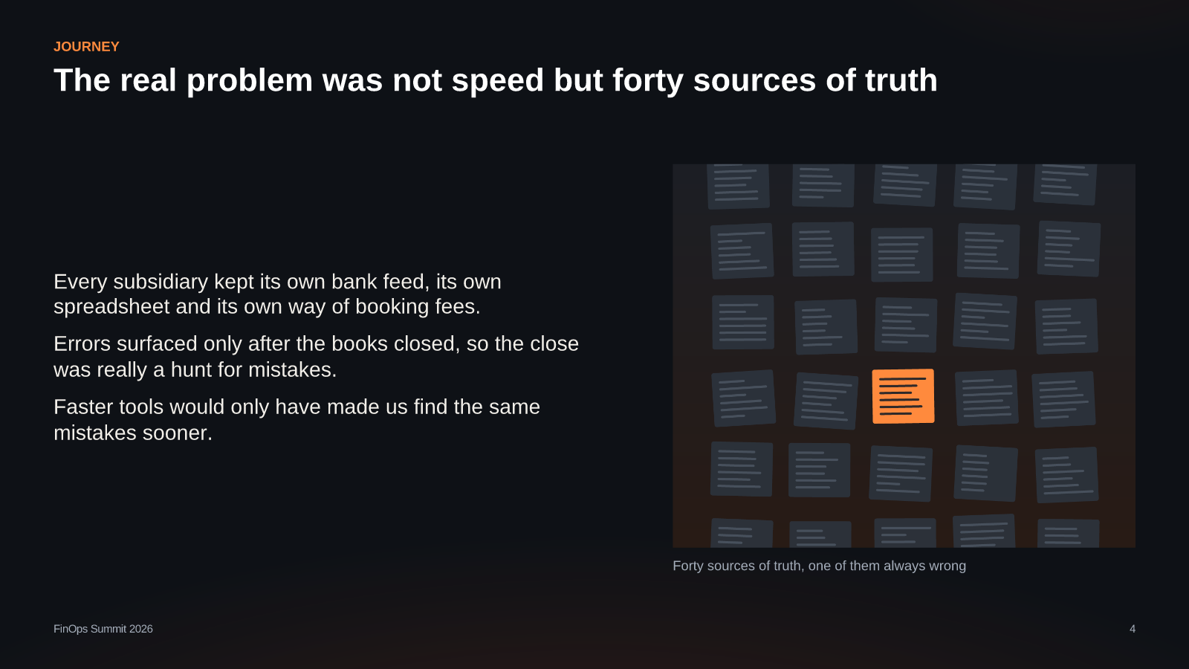
JOURNEY

Eighteen months, four decisions, one close that runs itself
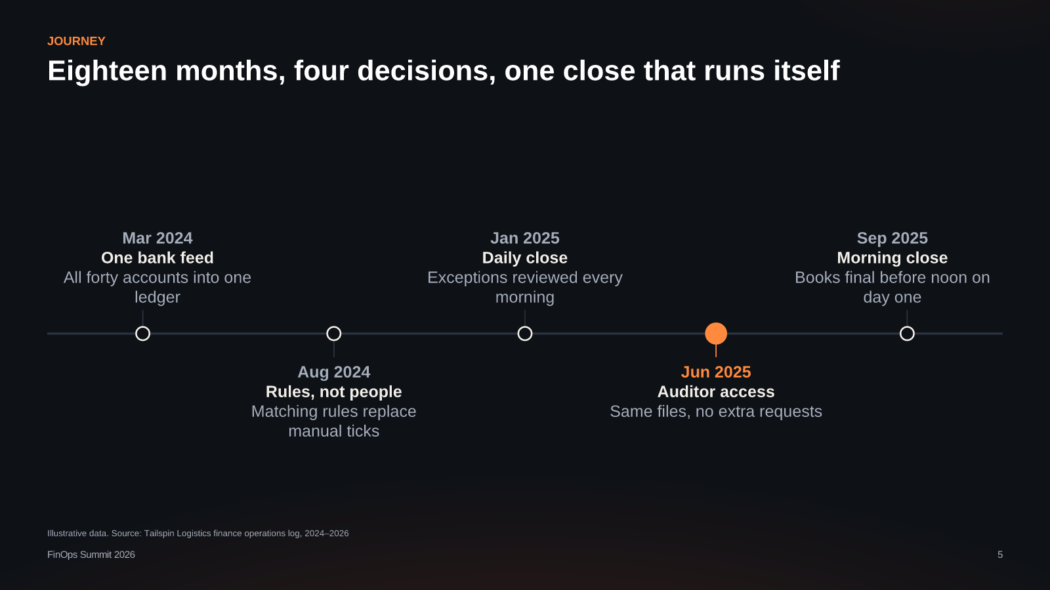
Illustrative data. Source: Tailspin Logistics finance operations log, 2024–2026
[Sources]
- Tailspin Logistics finance operations log, 2024–2026 — illustrative data

The close got fast the day we stopped treating it as an event
Once exceptions were cleared every morning, month-end was just another morning.
WHAT CHANGED

The close now ends before noon, and nobody waits for the numbers
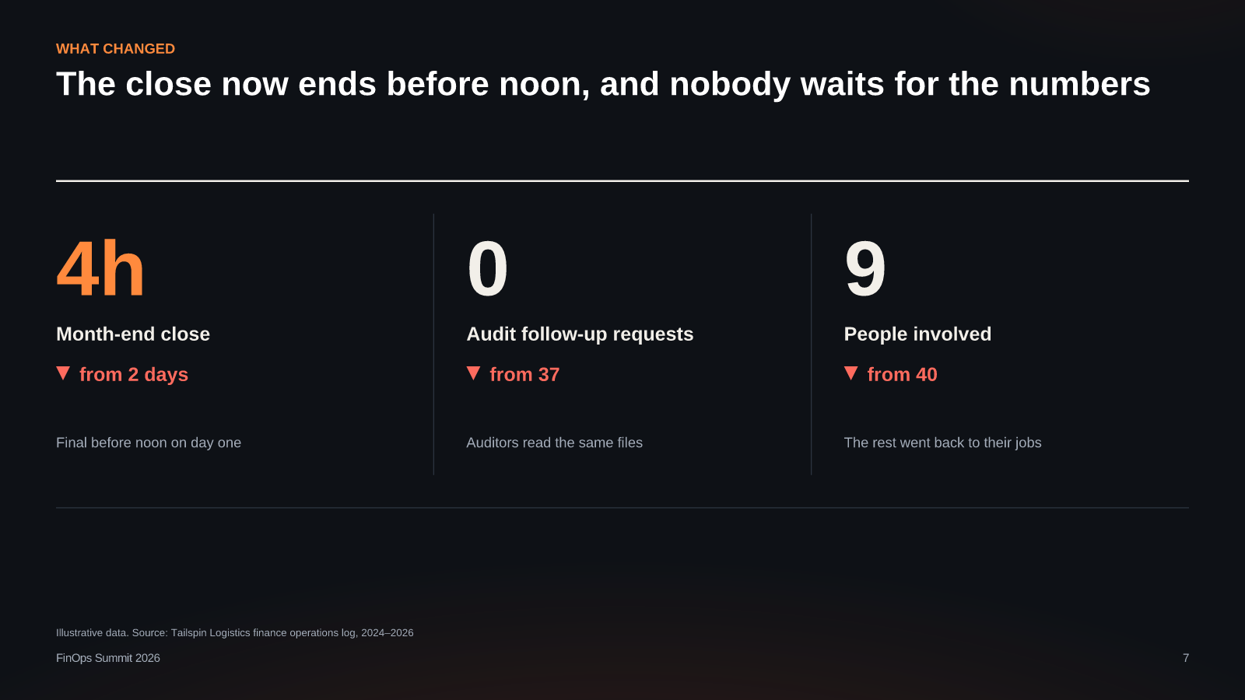
Illustrative data. Source: Tailspin Logistics finance operations log, 2024–2026
[Sources]
- Tailspin Logistics finance operations log, 2024–2026 — illustrative data
INSIGHT

Three lessons travel to any team that closes the books
Fix the sources, not the speed
Make exceptions daily
Share the same files
One feed and one ledger removed most errors before anyone looked for them.
A small daily queue beats a monthly mountain; the close becomes a non-event.
When auditors and managers read one version, arguments about numbers disappear.
INSIGHT

Teams that reconcile daily close their books three times faster
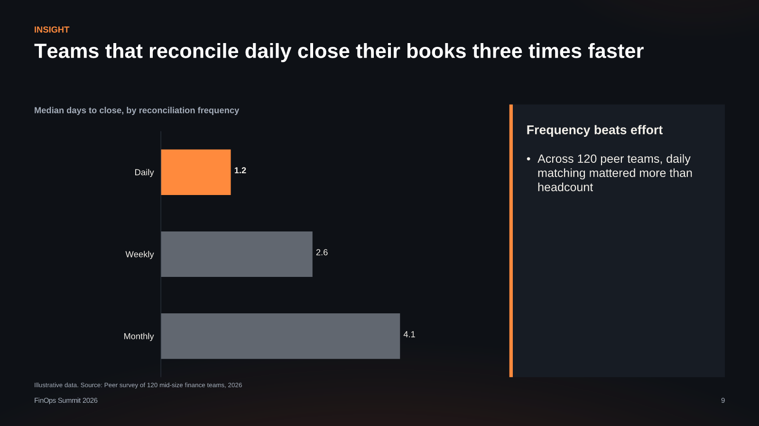
Illustrative data. Source: Peer survey of 120 mid-size finance teams, 2026
[Sources]
- Peer survey of 120 mid-size finance teams, 2026 — illustrative data

Tomorrow morning: reconcile one account before lunch
Then do it again the next day. That is the whole method.
finops@tailspin.example

