Shared vocabulary turns AI ambition into sound project choices
THE WHOLE SYSTEM

A successful AI project designs the full system, not only the model
Decision requested: Use this vocabulary to frame scope, owners, evidence, and trade-offs before selecting a solution.
1
Model capability
Select a model and define what it can see in each interaction.
2
Grounded knowledge
Retrieve trusted, current enterprise information rather than relying on model memory alone.
3
Controlled action
Give the model narrow, observable tools instead of unrestricted system access.
4
Measurement and control
Evaluate quality, enforce guardrails, and monitor cost and latency in production.
Source: OpenAI — Tokens and tokenization; Lewis et al. — Retrieval-Augmented Generation for Knowledge-Intensive NLP Tasks; OpenAI — Function calling guide; NIST — AI Risk Management Framework
[Sources]
- OpenAI — Tokens and tokenization — OpenAI — https://platform.openai.com/docs/concepts/tokens
- Lewis et al. — Retrieval-Augmented Generation for Knowledge-Intensive NLP Tasks — arXiv — https://arxiv.org/abs/2005.11401
- OpenAI — Function calling guide — OpenAI — https://platform.openai.com/docs/guides/function-calling
- NIST — AI Risk Management Framework — NIST — https://www.nist.gov/itl/ai-risk-management-framework
MODEL FUNDAMENTALS

Tokens and the context window set what the model can process in one interaction
Tokens are model-readable pieces of text
The context window is the model's working set
Context is a product design constraint
Text is split into tokens before processing; tokenization varies by model and language.
Instructions, conversation history, retrieved knowledge, and output all compete for the same finite window.
Decide what to include, summarize, retrieve, or omit so the model sees the relevant evidence.
Source: OpenAI — Tokens and tokenization
[Sources]
- OpenAI — Tokens and tokenization — OpenAI — https://platform.openai.com/docs/concepts/tokens
MODEL LIFECYCLE

Training builds a model; inference applies it to each request
Training changes model parameters
Inference applies the trained model
The distinction changes project choices
The learning process adjusts parameters from data to create general capabilities.
Each request combines an input and context with the existing model to produce an output.
Most enterprise work improves inference through prompts, retrieval, tools, and controls rather than training a model.
Source: Vaswani et al. — Attention Is All You Need; OpenAI — Fine-tuning guide
[Sources]
- Vaswani et al. — Attention Is All You Need — arXiv — https://arxiv.org/abs/1706.03762
- OpenAI — Fine-tuning guide — OpenAI — https://platform.openai.com/docs/guides/fine-tuning
GROUNDING

Embeddings make meaning searchable, and RAG uses that search to ground answers
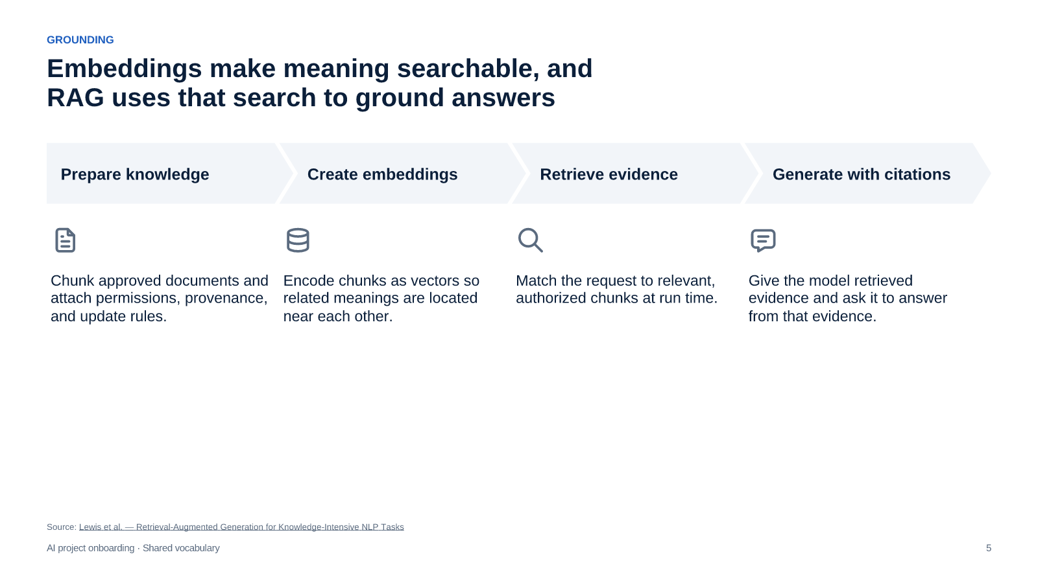
Source: Lewis et al. — Retrieval-Augmented Generation for Knowledge-Intensive NLP Tasks
[Sources]
- Lewis et al. — Retrieval-Augmented Generation for Knowledge-Intensive NLP Tasks — arXiv — https://arxiv.org/abs/2005.11401
ADAPTATION CHOICE

Prompting steers a model now, while fine-tuning changes behavior through training
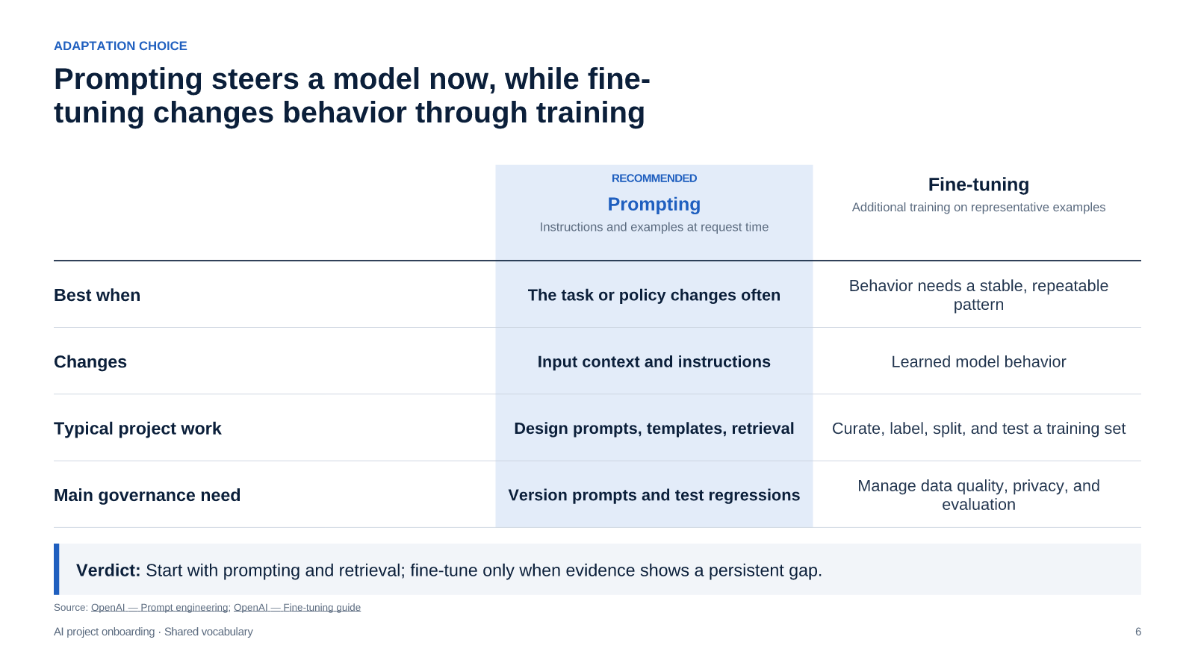
Source: OpenAI — Prompt engineering; OpenAI — Fine-tuning guide
[Sources]
- OpenAI — Prompt engineering — OpenAI — https://platform.openai.com/docs/guides/prompt-engineering
- OpenAI — Fine-tuning guide — OpenAI — https://platform.openai.com/docs/guides/fine-tuning
RELIABILITY

Hallucinations are plausible but unsupported outputs, so systems need multiple reduction layers
Ground each answer in approved evidence
Constrain important outputs
Clarify or escalate ambiguity
Govern the knowledge base
Retrieve trusted sources and require citations where users need to verify an answer.
Use structured schemas, validation, and policy checks before a response or action is accepted.
Ask for missing context and route high-consequence cases to a qualified person.
Set provenance, access, freshness, and review rules for the sources used at run time.
Source: Lewis et al. — Retrieval-Augmented Generation for Knowledge-Intensive NLP Tasks; OpenAI — Function calling guide; NIST — AI Risk Management Framework
[Sources]
- Lewis et al. — Retrieval-Augmented Generation for Knowledge-Intensive NLP Tasks — arXiv — https://arxiv.org/abs/2005.11401
- OpenAI — Function calling guide — OpenAI — https://platform.openai.com/docs/guides/function-calling
- NIST — AI Risk Management Framework — NIST — https://www.nist.gov/itl/ai-risk-management-framework
CONTROLLED ACTION

Tool use lets a model act, and function calling supplies the controlled contract
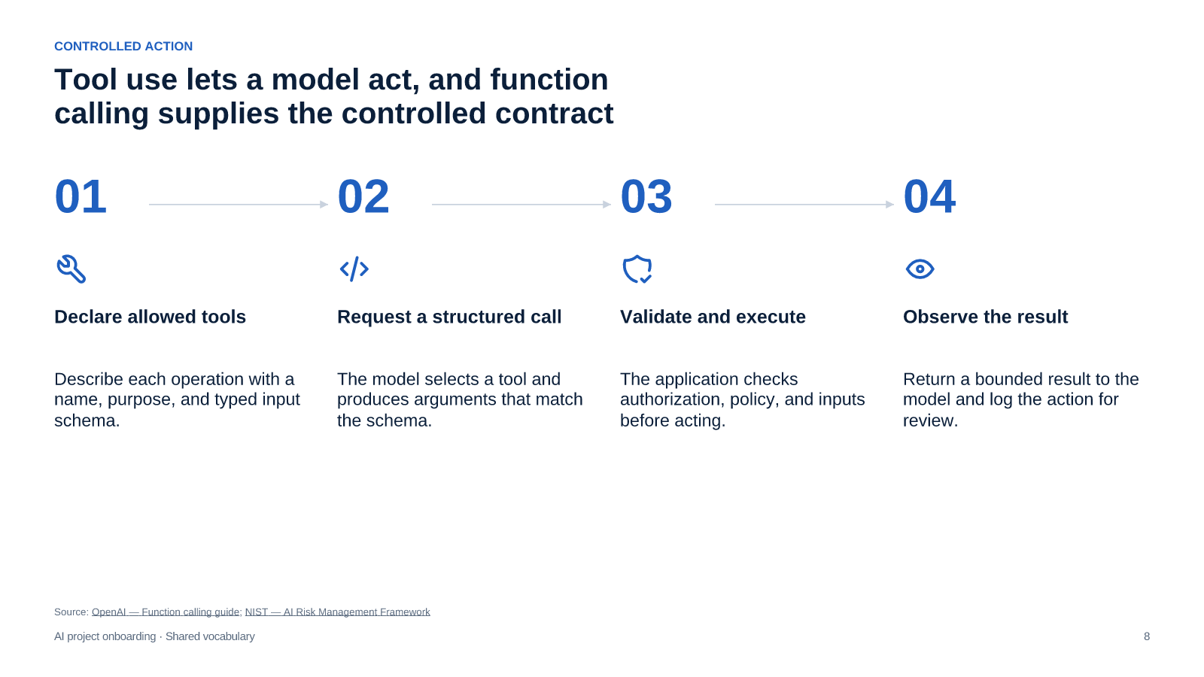
Source: OpenAI — Function calling guide; NIST — AI Risk Management Framework
[Sources]
- OpenAI — Function calling guide — OpenAI — https://platform.openai.com/docs/guides/function-calling
- NIST — AI Risk Management Framework — NIST — https://www.nist.gov/itl/ai-risk-management-framework
AI AGENTS

Agents repeat plan–act–observe loops, with memory treated as managed state
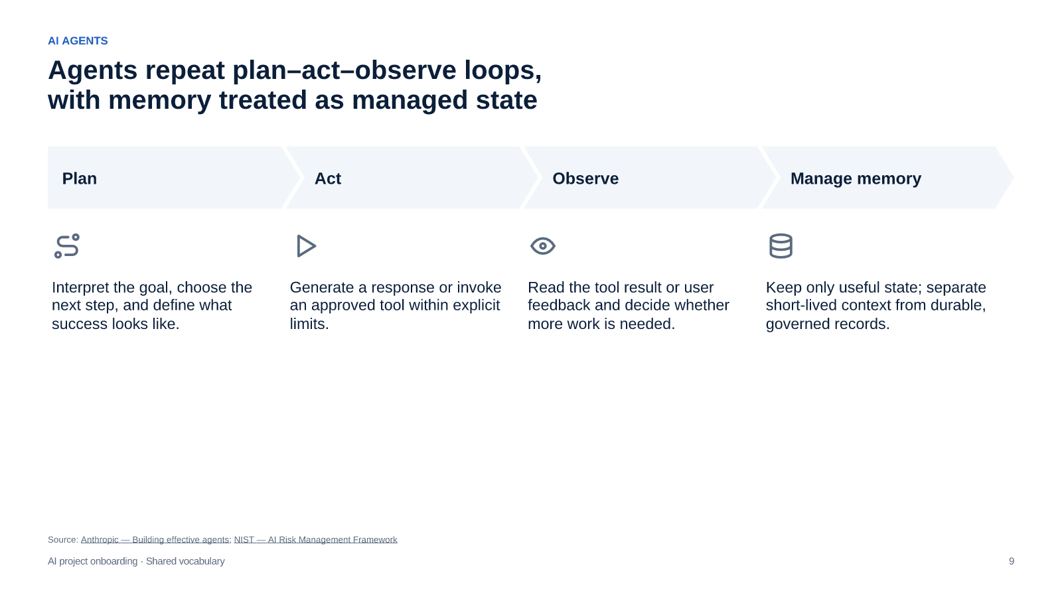
Source: Anthropic — Building effective agents; NIST — AI Risk Management Framework
[Sources]
- Anthropic — Building effective agents — Anthropic — https://www.anthropic.com/engineering/building-effective-agents
- NIST — AI Risk Management Framework — NIST — https://www.nist.gov/itl/ai-risk-management-framework
QUALITY AND SAFETY

Evaluation and guardrails make quality, safety, and operational control testable
Define success and failure
Test before release
Guard at run time
Monitor in production
Build representative tasks, expected outcomes, and unacceptable failure modes into an evaluation set.
Compare quality, safety, and tool-use behavior against agreed acceptance criteria.
Apply access controls, content policies, schemas, approvals, and human escalation.
Log outcomes, analyze failures, and refresh evaluations as the product and knowledge change.
Source: OpenAI — Evaluation best practices; NIST — AI Risk Management Framework
[Sources]
- OpenAI — Evaluation best practices — OpenAI — https://platform.openai.com/docs/guides/evals
- NIST — AI Risk Management Framework — NIST — https://www.nist.gov/itl/ai-risk-management-framework
OPERATING TRADE-OFFS

Capability, cost, and latency form a design trade-off to optimize deliberately
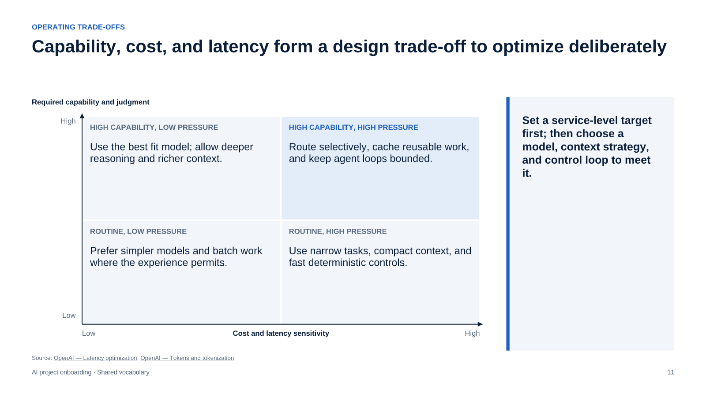
Source: OpenAI — Latency optimization; OpenAI — Tokens and tokenization
[Sources]
- OpenAI — Latency optimization — OpenAI — https://platform.openai.com/docs/guides/latency-optimization
- OpenAI — Tokens and tokenization — OpenAI — https://platform.openai.com/docs/concepts/tokens
FROM VOCABULARY TO CHARTER

A short discovery sequence turns the vocabulary into an AI project charter
Source: OpenAI — Evaluation best practices; NIST — AI Risk Management Framework; OpenAI — Latency optimization
[Sources]
- OpenAI — Evaluation best practices — OpenAI — https://platform.openai.com/docs/guides/evals
- NIST — AI Risk Management Framework — NIST — https://www.nist.gov/itl/ai-risk-management-framework
- OpenAI — Latency optimization — OpenAI — https://platform.openai.com/docs/guides/latency-optimization

