Forward Deployed Engineers turn AI pilots into working products
SlideCraft example
WHY NOW

AI companies hire FDEs because most AI pilots stall before production
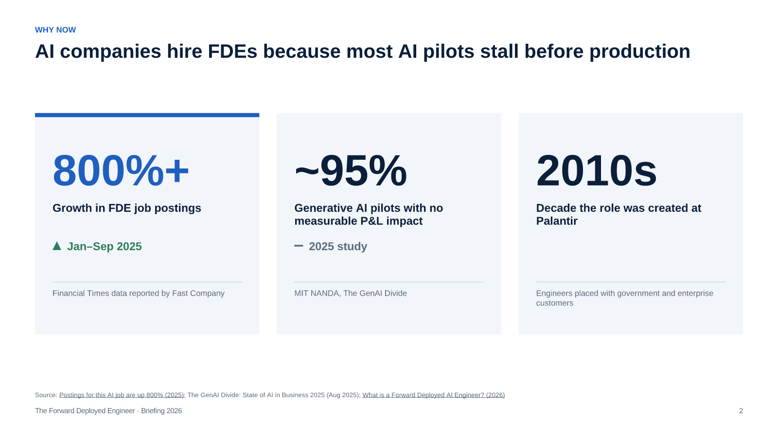
Source: Postings for this AI job are up 800% (2025); The GenAI Divide: State of AI in Business 2025 (Aug 2025); What is a Forward Deployed AI Engineer? (2026)
The growth figures differ by dataset; all of them show a several-fold rise. The point is the cause — pilots that never reach production.
[Sources]
- Postings for this AI job are up 800% — Fast Company, citing Financial Times data — 2025 — https://www.fastcompany.com/91435680/postings-for-this-ai-job-are-up-800
- The GenAI Divide: State of AI in Business 2025 — MIT NANDA — Aug 2025
- What is a Forward Deployed AI Engineer? — Paraform — 2026 — https://www.paraform.com/blog/forward-deployed-ai-engineer
WHAT IT IS

An FDE ships production software inside the customer's workflow
Role | Works | Delivers | Judged by
Forward Deployed Engineer | With the customer's team | Working software in production | Adoption and business value
Software engineer | In the product team | Features for many customers | Releases and quality
Solutions engineer | In the sales cycle | Demos and proofs of concept | Deals closed
Consultant | Next to the client | Analysis and recommendations | Decisions taken

Source: What is a Forward Deployed AI Engineer? (2026)
Typical question — is this a rebranded solutions engineer? No — the FDE is accountable for production use, not for closing the deal.
[Sources]
- What is a Forward Deployed AI Engineer? — Paraform — 2026 — https://www.paraform.com/blog/forward-deployed-ai-engineer
WHAT THEY DO

The FDE cycle runs from the user's desk to the core product
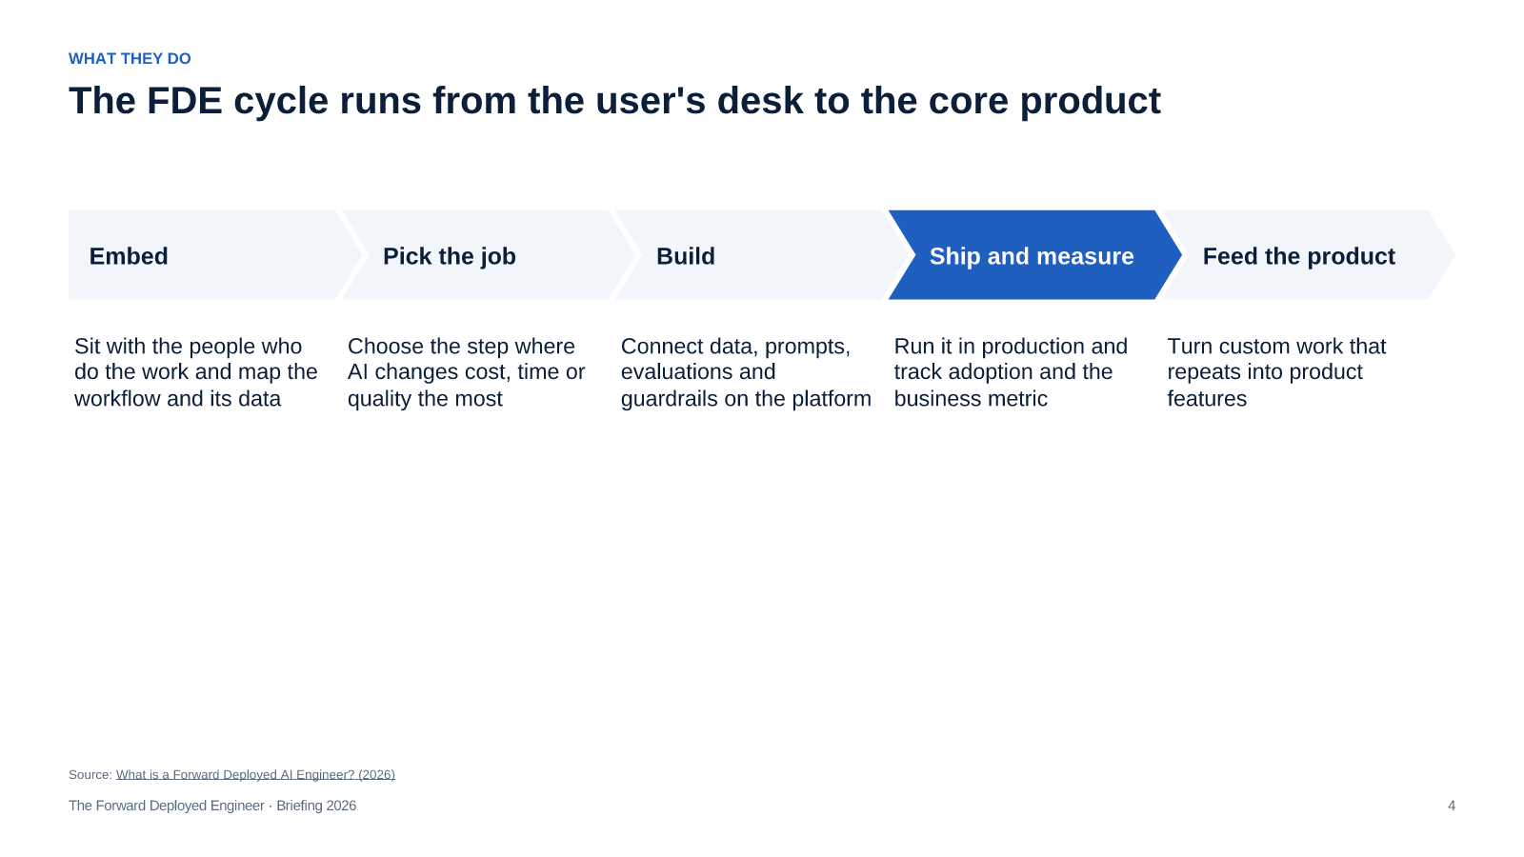
Source: What is a Forward Deployed AI Engineer? (2026)
Step four is where most pilots stop; the FDE is measured on it.
[Sources]
- What is a Forward Deployed AI Engineer? — Paraform — 2026 — https://www.paraform.com/blog/forward-deployed-ai-engineer
WHO TO HIRE

The profile combines production engineering, applied AI and customer judgement
Production engineering
Applied AI
Customer judgement
Full-stack and data skills; integrates with legacy systems and owns reliability after go-live
Works with model APIs, retrieval, evaluations and guardrails — and knows when not to use a model
Scopes problems with domain experts, explains trade-offs and says no to low-value requests
Source: What is a Forward Deployed AI Engineer? (2026)
Hire for production engineering first; applied AI can be learned faster than customer judgement.
[Sources]
- What is a Forward Deployed AI Engineer? — Paraform — 2026 — https://www.paraform.com/blog/forward-deployed-ai-engineer
WHAT TO DO

Start with one FDE on your highest-value AI use case
DECISION REQUESTED
Pilot one Forward Deployed Engineer for one quarter on a single production workflow
1
Pick one workflow with a measurable business metric
Head of AI · Month 1
2
Assign or hire one engineer with production and AI experience
CTO · Month 1
3
Embed the engineer with the team that owns the workflow
Business owner · Month 1–2
4
Ship to production and review the metric every week
FDE · Month 2–3
5
Decide: scale, turn into product, or stop
Leadership team · End of quarter
Ask for one decision — a one-quarter pilot with a named workflow and metric.

