Forward Deployed Engineers turn AI pilots into working products
SlideCraft example
WHY NOW

AI companies hire FDEs because most AI pilots stall before production
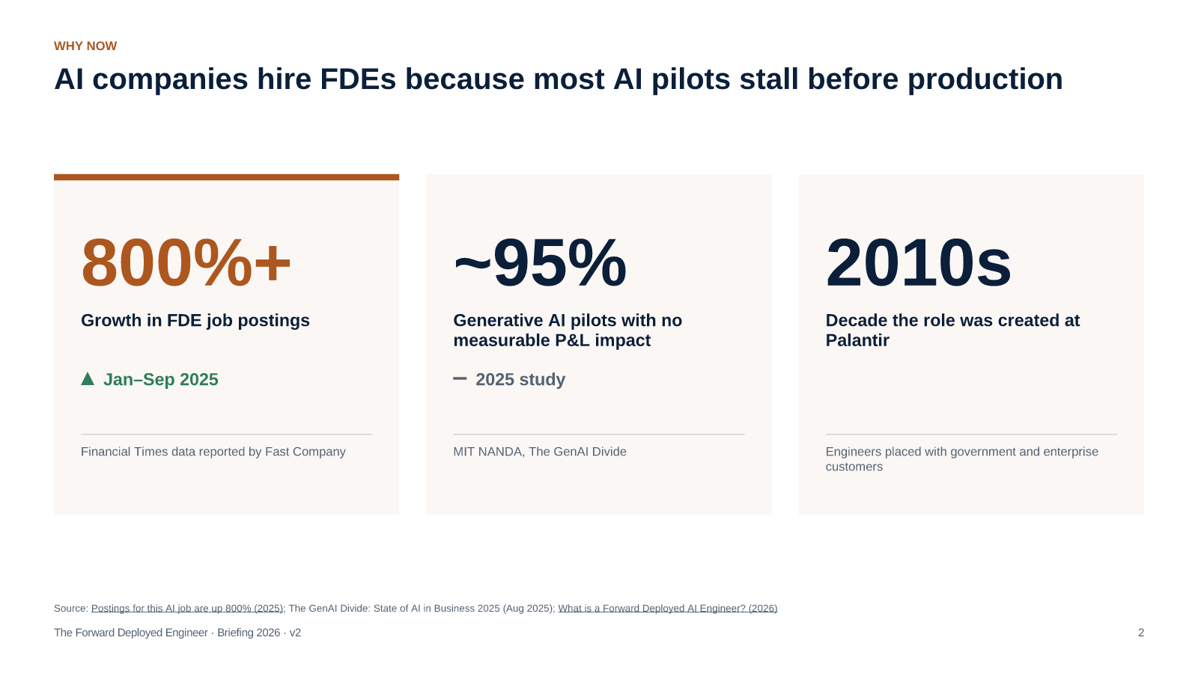
Source: Postings for this AI job are up 800% (2025); The GenAI Divide: State of AI in Business 2025 (Aug 2025); What is a Forward Deployed AI Engineer? (2026)
The growth figures differ by dataset; all of them show a several-fold rise. The point is the cause — pilots that never reach production.
[Sources]
- Postings for this AI job are up 800% — Fast Company, citing Financial Times data — 2025 — https://www.fastcompany.com/91435680/postings-for-this-ai-job-are-up-800
- The GenAI Divide: State of AI in Business 2025 — MIT NANDA — Aug 2025
- What is a Forward Deployed AI Engineer? — Paraform — 2026 — https://www.paraform.com/blog/forward-deployed-ai-engineer
WHERE IT FITS

The FDE owns the middle of the AI value chain, where most pilots stall
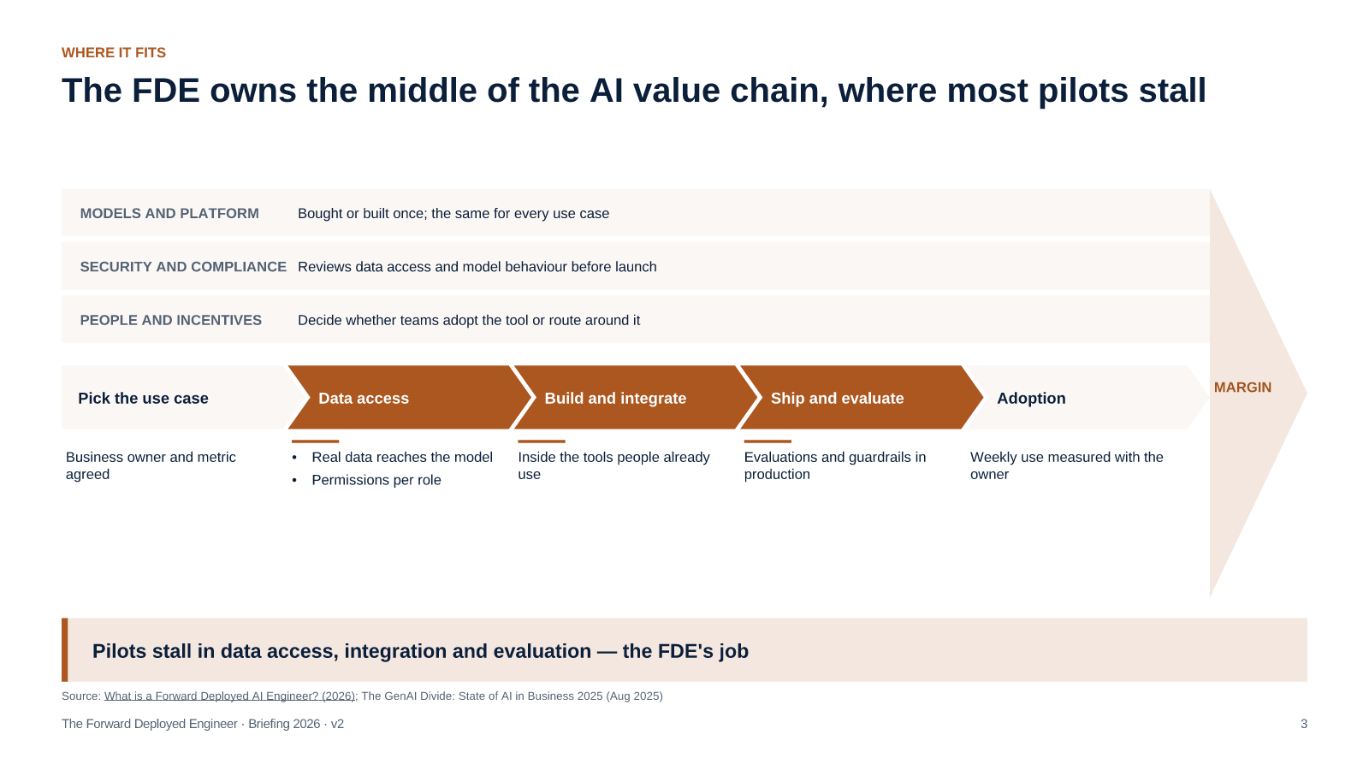
Source: What is a Forward Deployed AI Engineer? (2026); The GenAI Divide: State of AI in Business 2025 (Aug 2025)
The model is rarely the bottleneck. The work in the middle is where an embedded engineer changes the outcome.
[Sources]
- What is a Forward Deployed AI Engineer? — Paraform — 2026 — https://www.paraform.com/blog/forward-deployed-ai-engineer
- The GenAI Divide: State of AI in Business 2025 — MIT NANDA — Aug 2025
WHAT THEY DO

The FDE cycle runs from the user's desk to the core product
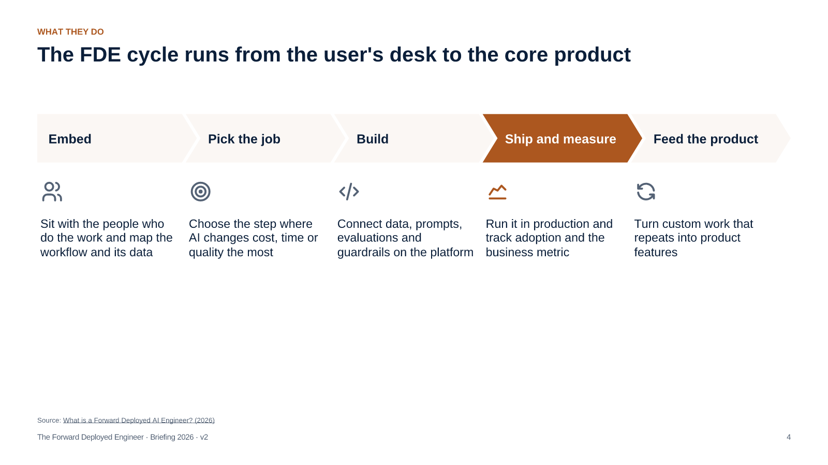
Source: What is a Forward Deployed AI Engineer? (2026)
Step four is where most pilots stop; the FDE is measured on it.
[Sources]
- What is a Forward Deployed AI Engineer? — Paraform — 2026 — https://www.paraform.com/blog/forward-deployed-ai-engineer
WHO TO HIRE

The profile combines production engineering, applied AI and customer judgement
Production engineering
Applied AI
Customer judgement
Full-stack and data skills; integrates with legacy systems and owns reliability after go-live
Works with model APIs, retrieval, evaluations and guardrails — and knows when not to use a model
Scopes problems with domain experts, explains trade-offs and says no to low-value requests
Source: What is a Forward Deployed AI Engineer? (2026)
Hire for production engineering first; applied AI can be learned faster than customer judgement.
[Sources]
- What is a Forward Deployed AI Engineer? — Paraform — 2026 — https://www.paraform.com/blog/forward-deployed-ai-engineer
WHAT HAS TO CHANGE

Strategy and platform are usually ready; staff placement and skills are not
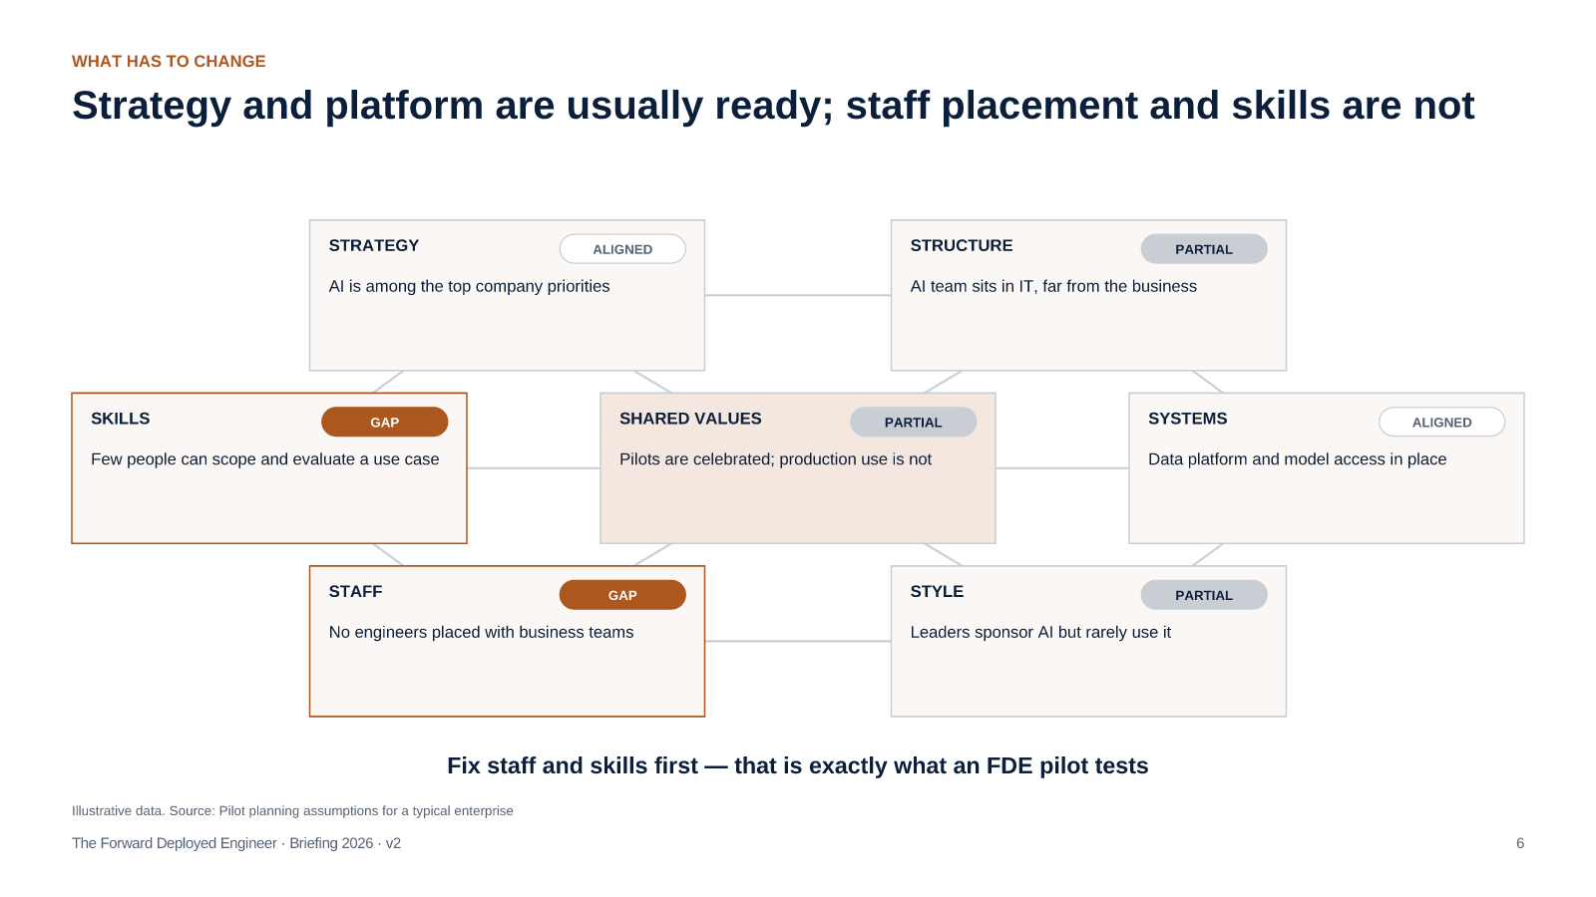
Illustrative data. Source: Pilot planning assumptions for a typical enterprise
A typical starting point, not a measured assessment — rate your own organisation before the pilot.
[Sources]
- Pilot planning assumptions for a typical enterprise — illustrative data
THE PILOT

The pilot targets 40 weekly users and a third of tasks automated by week 12
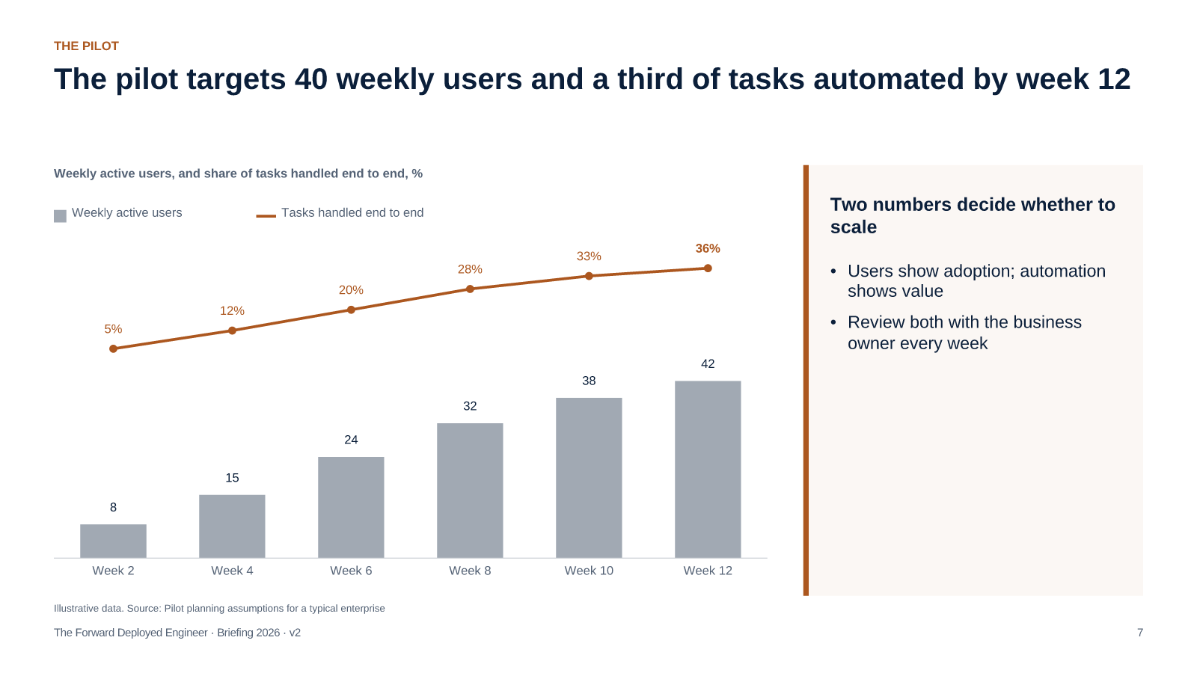
Illustrative data. Source: Pilot planning assumptions for a typical enterprise
Targets are planning assumptions; set your own with the business owner in week one.
[Sources]
- Pilot planning assumptions for a typical enterprise — illustrative data
THE PILOT

A one-quarter pilot costs about $206k, two-thirds of it the engineer
Item | Month 1 | Month 2 | Month 3 | Total
Forward Deployed Engineer | $45k | $45k | $45k | $135k
Model and platform usage | $8k | $12k | $15k | $35k
Business owner time | $6k | $6k | $6k | $18k
Evaluation and security review | $10k | $4k | $4k | $18k
Total | $69k | $67k | $70k | $206k

Illustrative data. Source: Pilot planning assumptions for a typical enterprise
Planning figures for a typical enterprise; replace with your own rates.
[Sources]
- Pilot planning assumptions for a typical enterprise — illustrative data
WHAT TO DO

Approve one FDE on your highest-value AI workflow for one quarter
DECISION REQUESTED
Approve a one-quarter pilot, about $206k, with one Forward Deployed Engineer on one production workflow
1
Pick one workflow with a measurable business metric
Head of AI · Month 1
2
Assign or hire one engineer with production and AI experience
CTO · Month 1
3
Embed the engineer with the team that owns the workflow
Business owner · Month 1–2
4
Ship to production and review users and automation weekly
FDE · Month 2–3
5
Decide: scale, turn into product, or stop
Leadership team · End of quarter
Ask for one decision — a one-quarter pilot with a named workflow, budget and metrics.

