The ERP programme is on budget but six weeks late; two decisions keep go-live in Q1
Programme office
SUMMARY

Delivery is recoverable if we decide on data migration scope today
Decision requested: Approve the reduced migration scope and the second rehearsal budget of €0.4M
1
Spend is 2% under plan at €18.4M of €31M
Forecast at completion holds at €30.6M including contingency.
2
Data migration is six weeks behind the plan
Legacy customer records need more cleansing than estimated.
3
Two decisions protect a Q1 2027 go-live
Narrow migration scope and add a second cut-over rehearsal.
Illustrative data. Source: Programme office status report, 30 Sep 2026
[Sources]
- Programme office status report, 30 Sep 2026 — illustrative data
STATUS

Budget and benefits are on track; schedule is the one red flag
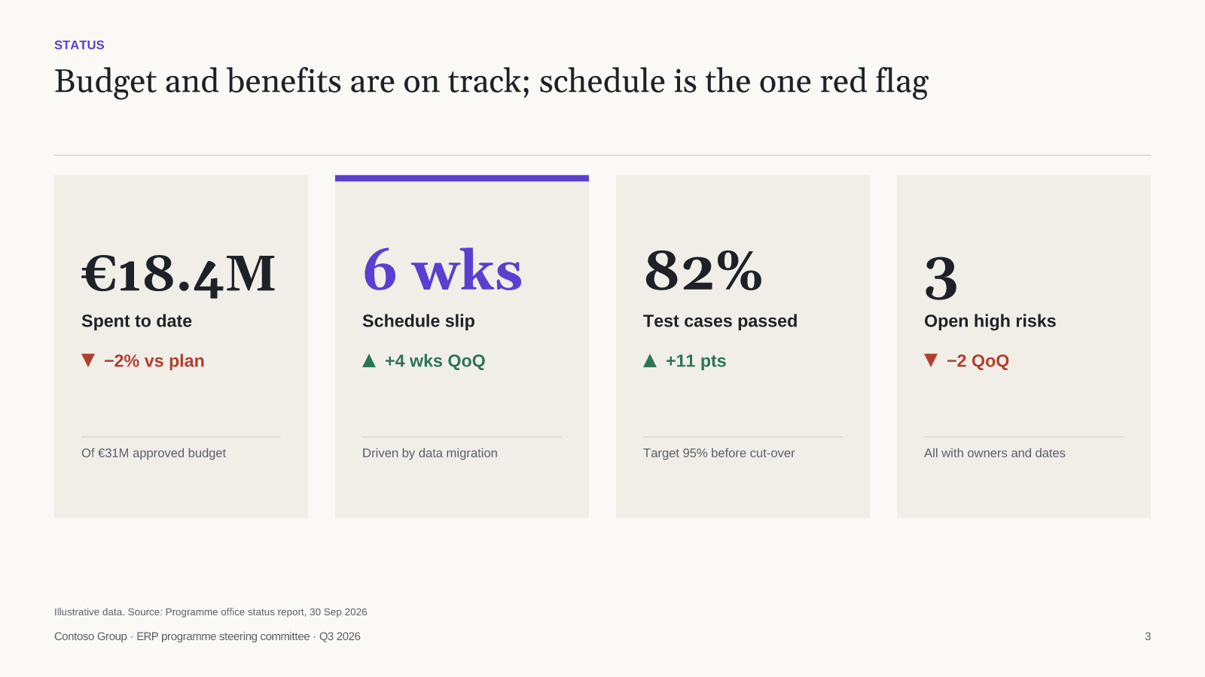
Illustrative data. Source: Programme office status report, 30 Sep 2026
[Sources]
- Programme office status report, 30 Sep 2026 — illustrative data
STATUS

Migration now ends in December; cut-over holds if the rehearsal is added
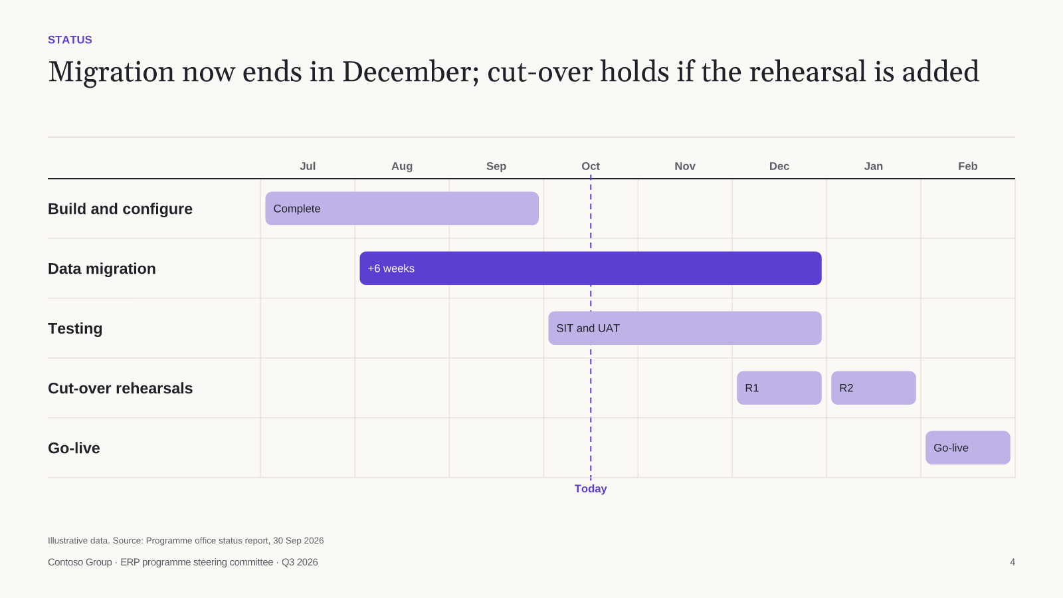
Illustrative data. Source: Programme office status report, 30 Sep 2026
[Sources]
- Programme office status report, 30 Sep 2026 — illustrative data
DECISIONS

Narrowing migration scope is the only option that protects the Q1 go-live
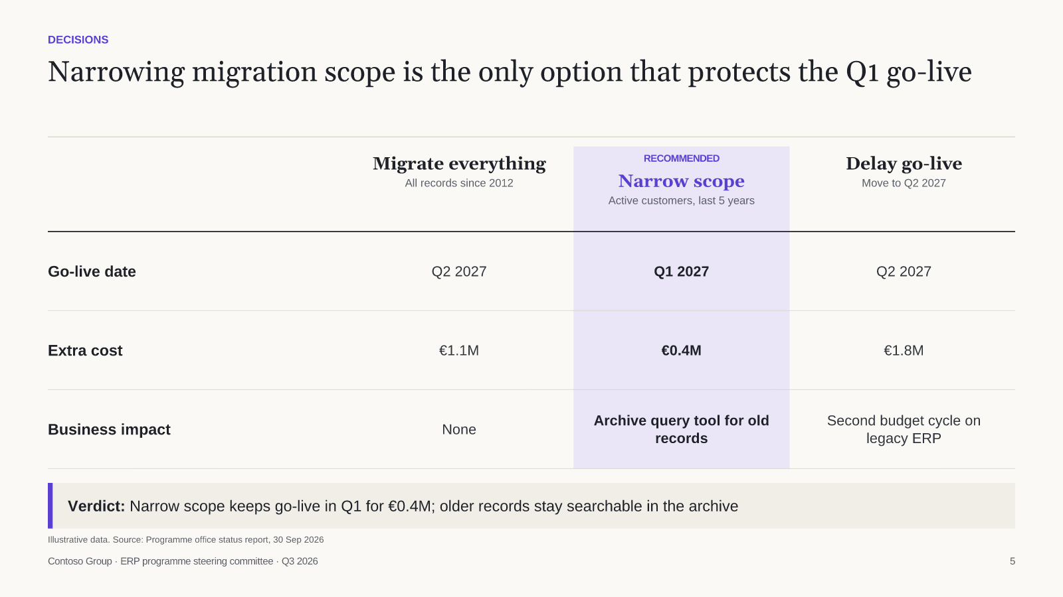
Illustrative data. Source: Programme office status report, 30 Sep 2026
[Sources]
- Programme office status report, 30 Sep 2026 — illustrative data
NEXT STEPS

Four actions over the next six weeks get migration back on plan

