Five European cities that make a perfect first trip
SlideCraft travel desk
THE LANDSCAPE

Prague and Berlin deliver big-city sights at two-thirds of the daily cost of Paris
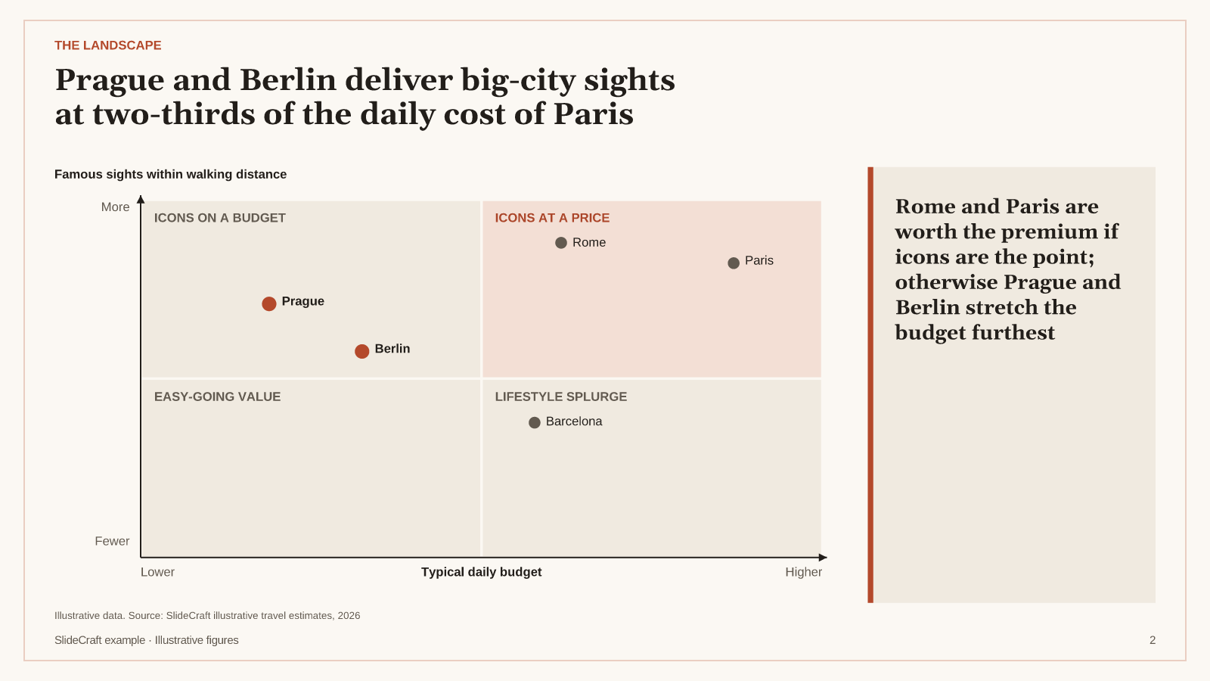
Illustrative data. Source: SlideCraft illustrative travel estimates, 2026
Positions are illustrative judgements from typical budgets and sight density in the historic centres.
[Sources]
- SlideCraft illustrative travel estimates, 2026 — illustrative data
WHICH CITY FOR WHICH TRAVELLER

Every city wins a different kind of trip — match it to what you love most
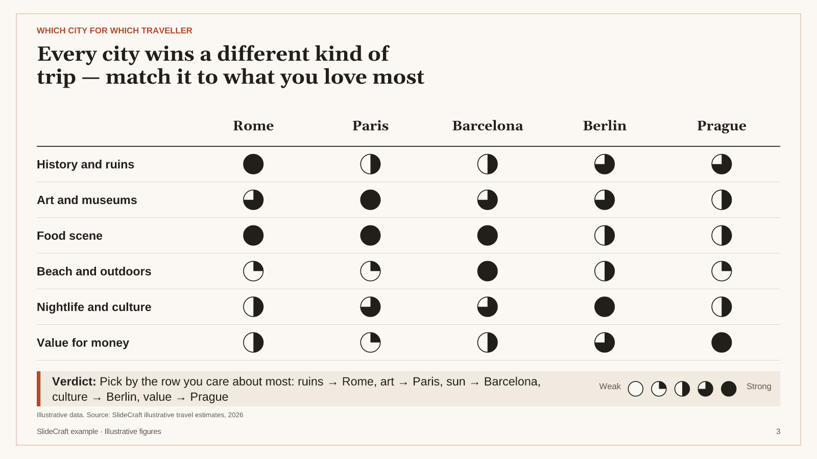
Illustrative data. Source: SlideCraft illustrative travel estimates, 2026
[Sources]
- SlideCraft illustrative travel estimates, 2026 — illustrative data
WHAT IT COSTS

A day in Paris costs almost twice as much as a day in Prague
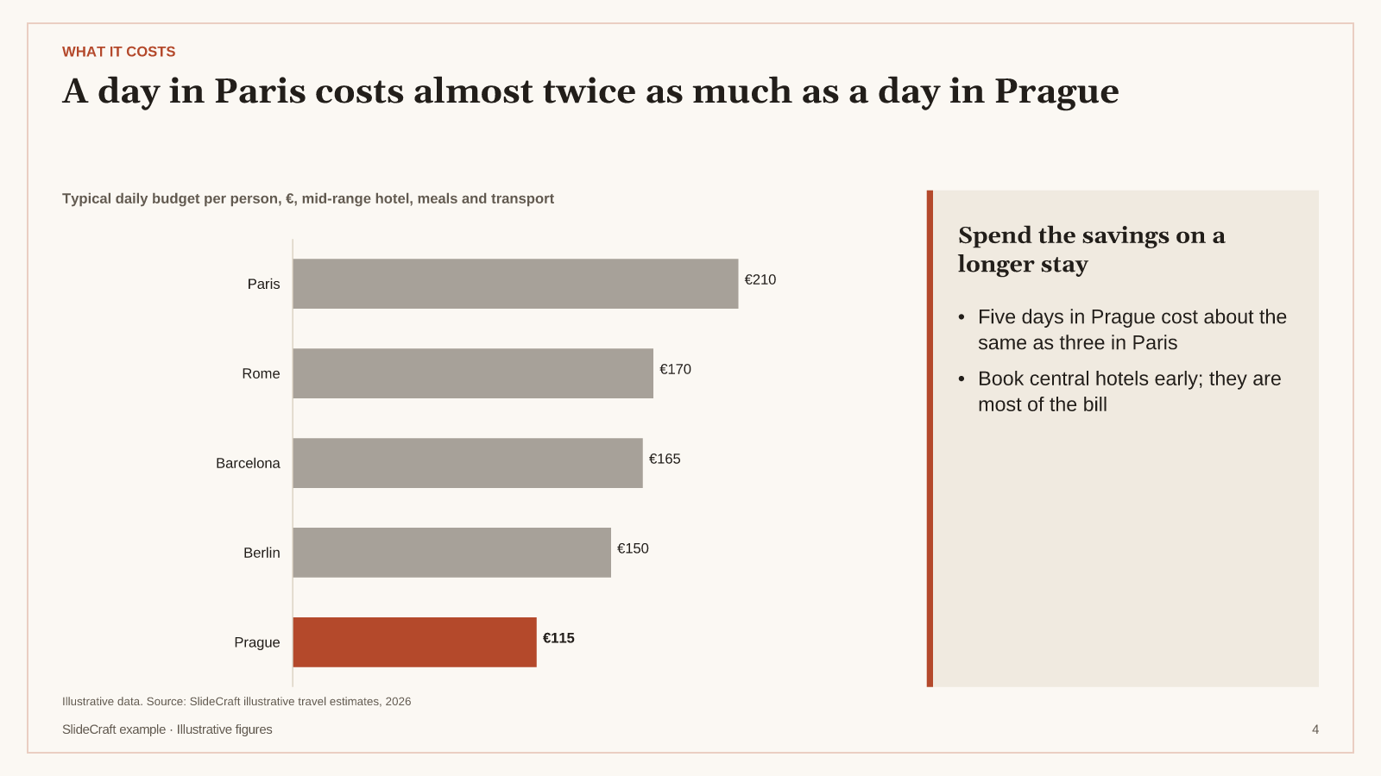
Illustrative data. Source: SlideCraft illustrative travel estimates, 2026
[Sources]
- SlideCraft illustrative travel estimates, 2026 — illustrative data
PICK YOURS

Go in spring or early autumn — every city is at its best, and cheaper, outside July and August
If you love… | Go to | Best months | Daily budget | Don't miss
History and ruins | Rome | Apr–May · Sep–Oct | €170 | Colosseum at opening time
Art and museums | Paris | Apr–Jun · Sep–Oct | €210 | Musée d'Orsay on a weekday
Sun and food | Barcelona | May–Jun · Sep | €165 | Sagrada Família and the Boqueria
Culture and nightlife | Berlin | May–Sep | €150 | Museum Island and a Kreuzberg evening
Value and old-town charm | Prague | Apr–Jun · Sep–Oct | €115 | Charles Bridge at sunrise

Illustrative data. Source: SlideCraft illustrative travel estimates, 2026
[Sources]
- SlideCraft illustrative travel estimates, 2026 — illustrative data

